## Standard Template Library

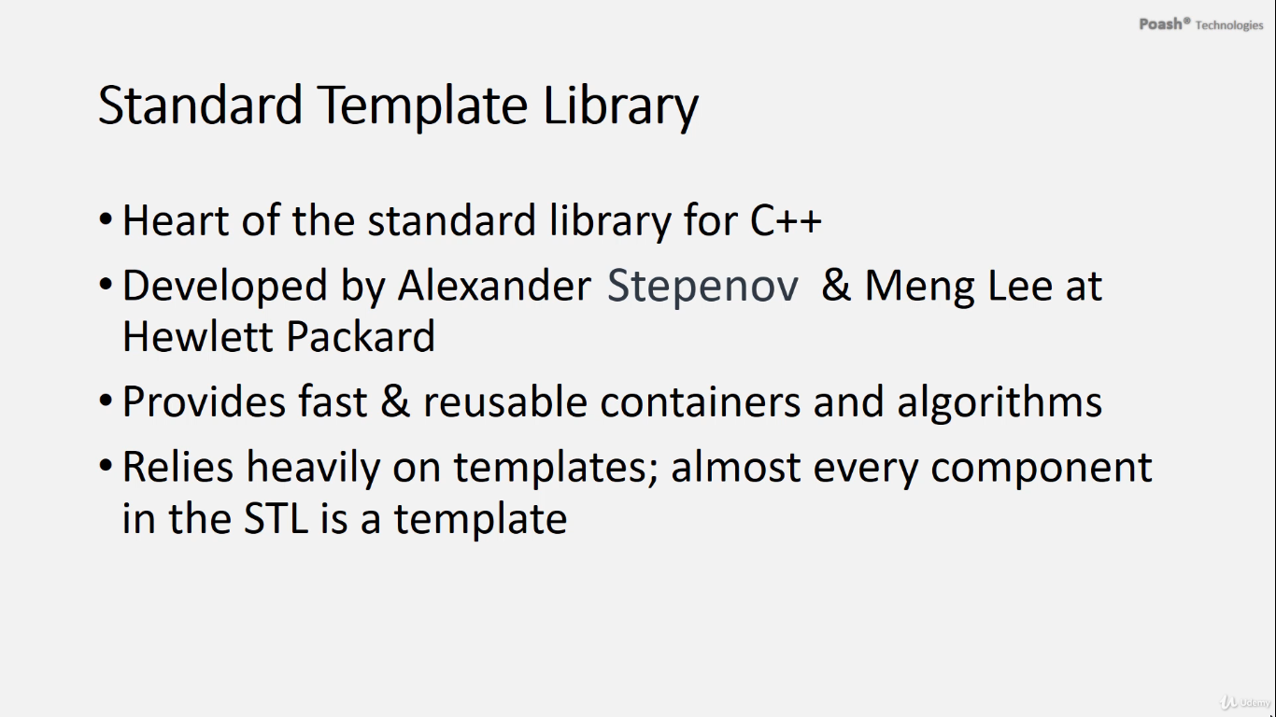

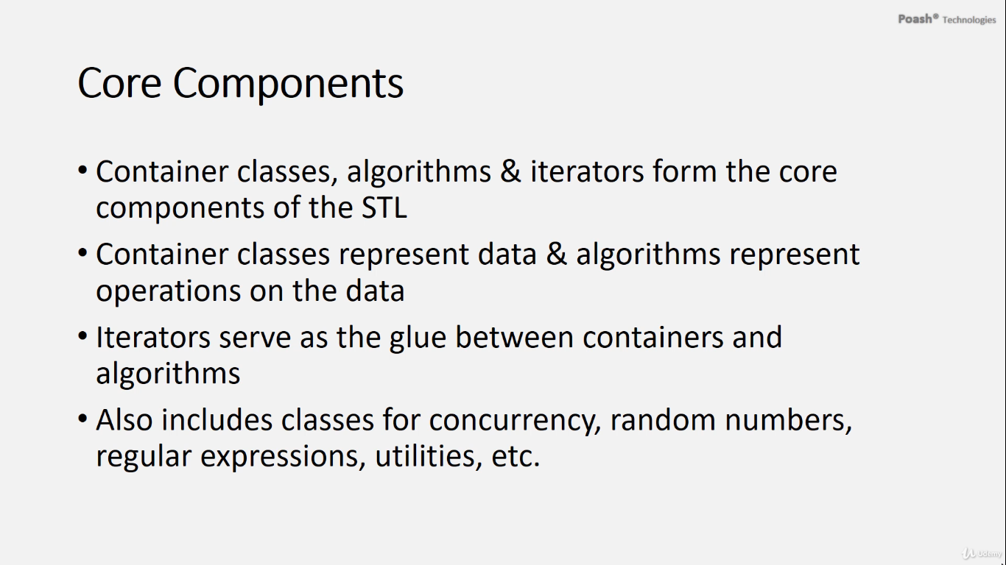

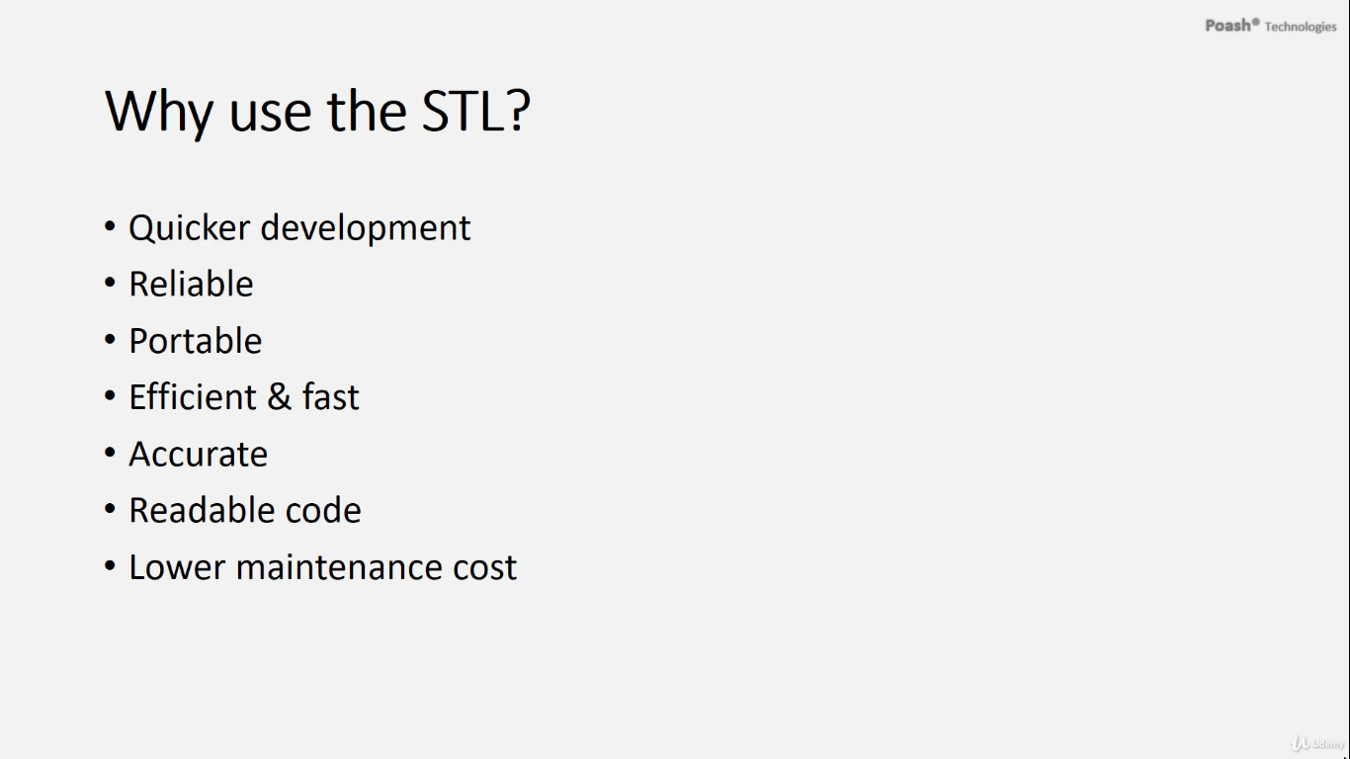

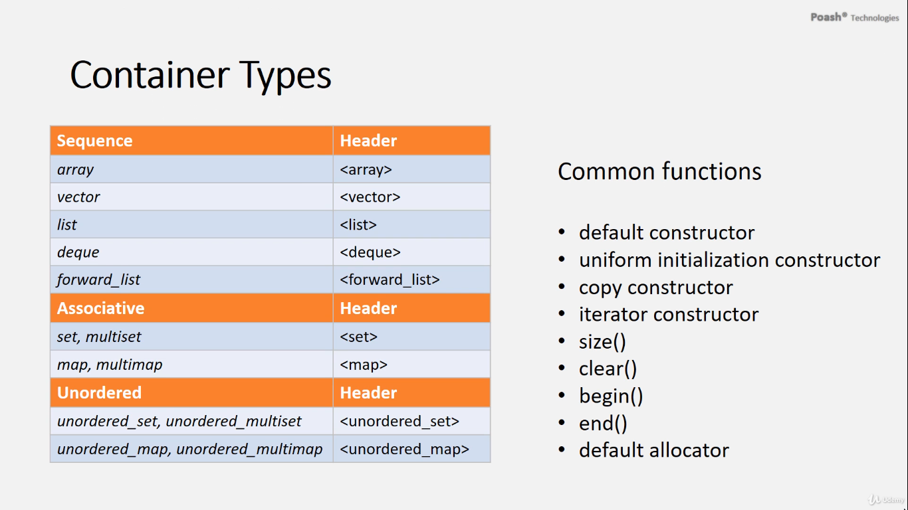

STL, or the Standard Template Library, is a fundamental part of the C++ standard library, developed by Alexander Stepanov and Meng Lee at Hewlett Packard. It offers a collection of reusable containers and algorithms, heavily relying on templates for flexibility and generic programming.

The core components of STL include container classes, algorithms, and iterators. Containers hold data, algorithms perform operations on the data, and iterators act as intermediaries facilitating interaction between containers and algorithms. Additional features in STL include classes for concurrency, random numbers, regular expressions, utilities, and more, introduced in C++11.

STL is crucial for several reasons:

1. **Efficiency and Reliability:** STL provides pre-implemented data structures and algorithms developed by experts, ensuring efficiency, reliability, and accuracy. This eliminates the need for developers to implement these components from scratch.
2. **Quicker Development:** By leveraging STL's pre-built components, developers can expedite development time significantly, as they can focus on higher-level logic rather than low-level implementations.
3. **Readability and Maintainability:** STL promotes cleaner and more concise code, enhancing readability. Additionally, since STL components are well-tested and standardized, maintaining code becomes easier and more cost-effective.

STL containers are categorized into three main types: sequence, associative, and unordered containers (introduced in C++11). Despite their differences, all containers share common functionality:

* Default constructor and uniform initialization constructor
* Copy constructor
* Constructor accepting iterators for initialization
* Functions for accessing size and clearing the container (size() and clear())
* Functions for creating iterators to traverse the container (begin() and end())

Moreover, STL containers rely on allocators for memory management, as they don't manage memory directly. Instead, containers use allocator classes internally for memory allocation and deallocation.

# Sequence container

# std::array

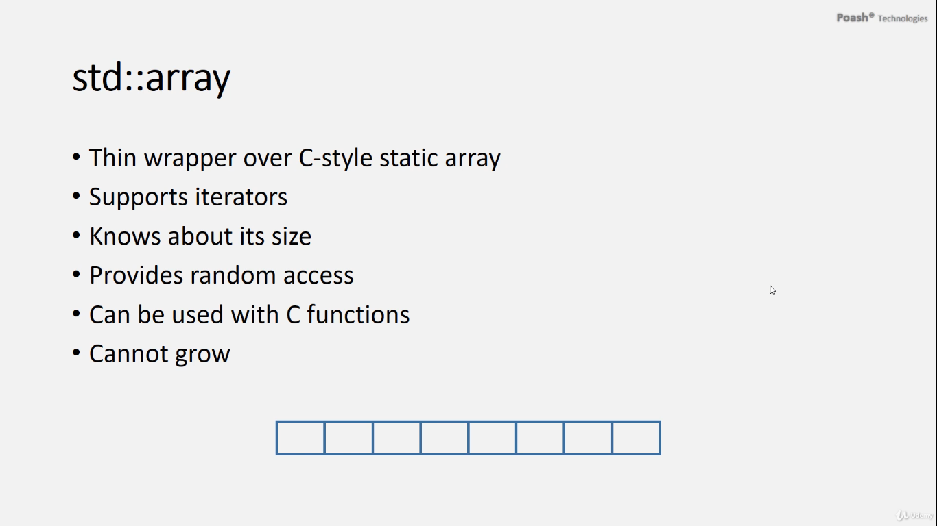

* The array class in C++ serves as a minimal wrapper over C-style static arrays, internally storing elements in a static array format.
* Advantages of using the array class over raw static arrays include support for iterators, facilitating access to its elements and awareness of its size. Furthermore, the array class allows for random access to elements and seamless integration with C functions.
* However, it's crucial to recognize that array instances cannot expand dynamically since they are constructed at compile time. As a result, they lack the capability to resize dynamically during program execution

# Iterators

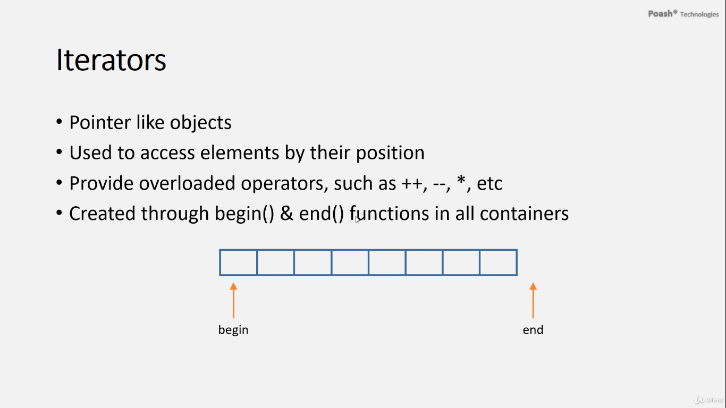

An iterator is akin to a pointer-like object enabling access to elements within a container based on their position.

Iterators are equipped with numerous overloaded operators, including the asterisk operator (*) for accessing and modifying container elements. They are typically created using the **begin()** and **end()** functions available in all containers.

* **begin()** returns an iterator pointing to the first container element.
* **end()** returns an iterator indicating the position beyond the last element, commonly used for termination conditions in loops and algorithms.

It's essential never to dereference the **end()** iterator, as it doesn't point to a valid element. Instead, it's utilized to denote the end of a range and can be used to check for the success or failure of certain operations or algorithms.

**In many cases**, algorithms return the **end()** iterator upon failure, allowing for easy comparison with iterators to assess the algorithm's success.

For arrays, iterators can be obtained by calling **begin()** to retrieve the iterator to the first element, facilitating iteration over array elements. Alternatively, a range-based for loop can be utilized, which internally leverages **begin()** and **end()** iterators for iteration.Top of Form

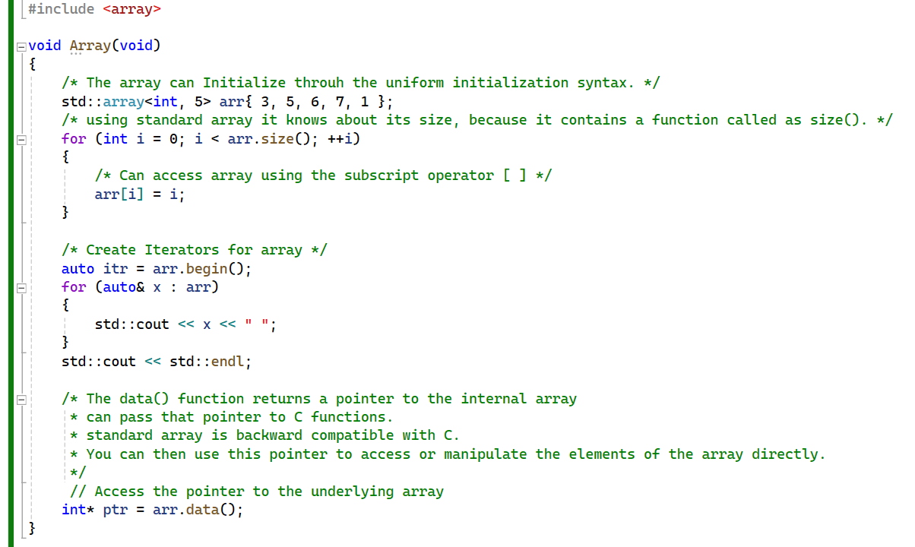

# std:: vector

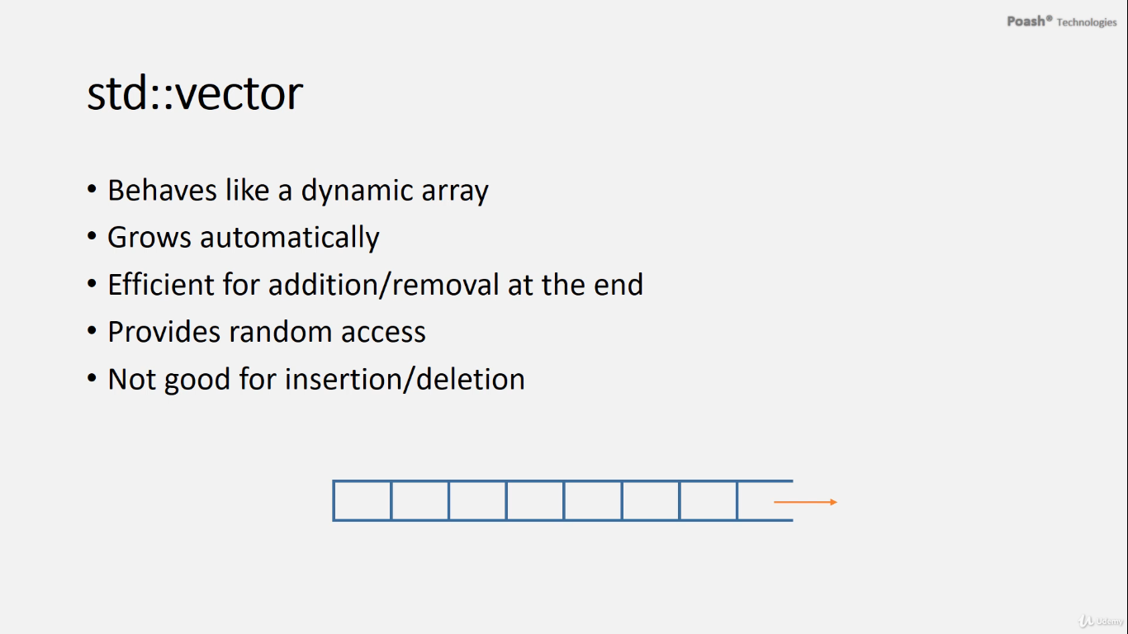

* std::vector behaves like a dynamic array, so it can grow automatically. It is efficient for the addition and removal of elements at the end. Because it is internally implemented as an array, it provides random access.
* To insert an element at a specific position in a vector, you use the **insert()** function along with an iterator pointing to the desired position. This iterator can be obtained using the **begin()** function or any other iterator.
* However, it's crucial to consider the performance **implications** of this operation. Inserting an element may require shifting existing elements, which involves copying elements and can be computationally expensive, especially for large vectors or when dealing with **user-defined objects.**
* Vectors are well-suited for operations that necessitate random access to elements due to their contiguous memory allocation. However, they are not optimal for insertion and deletion operations anywhere other than at the back. This is because inserting or deleting elements from the middle or front of a vector can be **inefficient**, as it may require **shifting** subsequent elements to accommodate the change, leading to potentially costly reallocation and copying operations. For such scenarios, other data structures like lists or deques may be more appropriate.

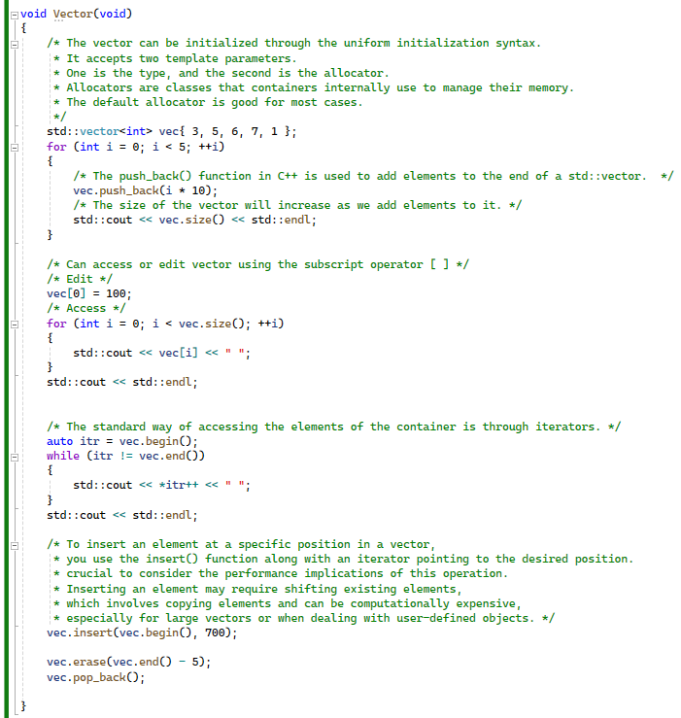

# std::deque

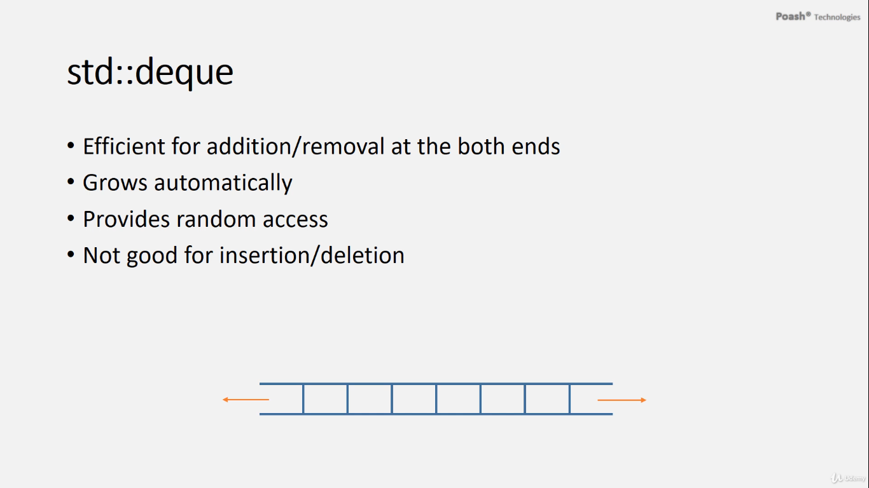

The deque, short for double-ended queue, is a container similar to the vector but with the capability to add and remove elements from both ends efficiently. This makes it suitable for operations involving insertion and removal at both ends. Like a vector, a deque can dynamically resize itself and provides random access to its elements. However, similar to vectors, deques are not optimal for insertion and deletion operations except at the ends. Despite this limitation, deques offer flexibility and efficiency for scenarios requiring bidirectional access and dynamic resizing.

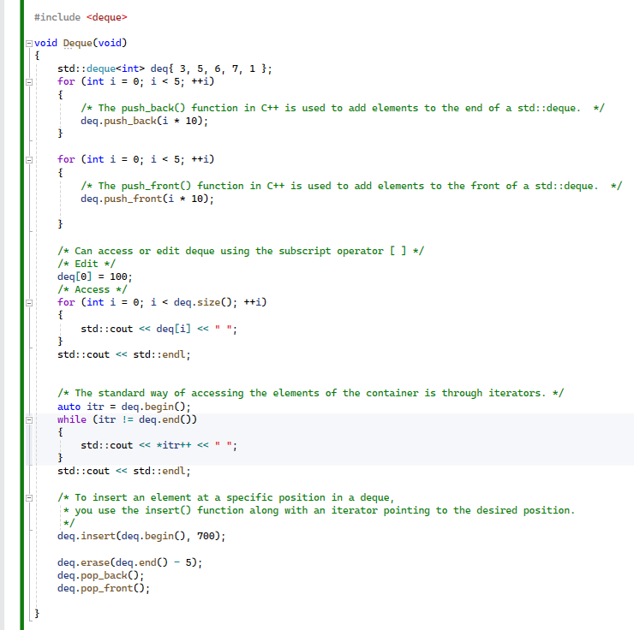

1. **pop_back()**: This function removes the last element of a container, such as a vector or deque. It's commonly used when you want to eliminate the last-added element or when you need to shrink the size of the container by one.
2. **pop_front()**: This function removes the first element of a container, typically used with list containers. It's useful when you need to remove elements from the beginning of the container.
3. **erase()**: This function removes elements from a container based on the position or a range. It's widely used with vectors, lists, sets, and other containers. You can specify the position of the element you want to remove, or a range of elements, and it will eliminate them from the container.

# std::list

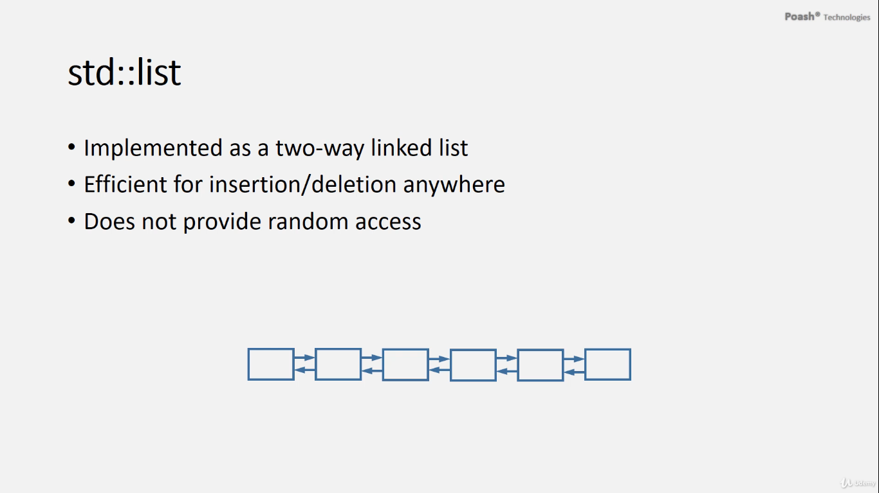

* The list and forward list are implemented as double and single linked lists, respectively. Each node in the list contains pointers to the next and previous nodes, facilitating traversal in both forward and backward directions. Lists excel at insertion and deletion operations, which can be performed at any position within the list. However, due to their structure, lists do not offer random access to elements. Instead, they provide efficient support for sequential access and are particularly suited for scenarios where frequent insertion and deletion operations are required at various positions within the list.
* Lists excel at insertions and deletions, offering constant-time complexity for these operations regardless of the position within the list. This efficiency stems from the structure of linked lists, where each node contains pointers to the next and previous nodes. Consequently, insertions and deletions can be performed quickly at any location within the list. This makes lists ideal for scenarios involving frequent modifications to the container's contents, particularly when random access is not required. Although the use of pointers adds overhead, it enables traversal of the list in both forward and backward directions, enhancing the flexibility of list operations.

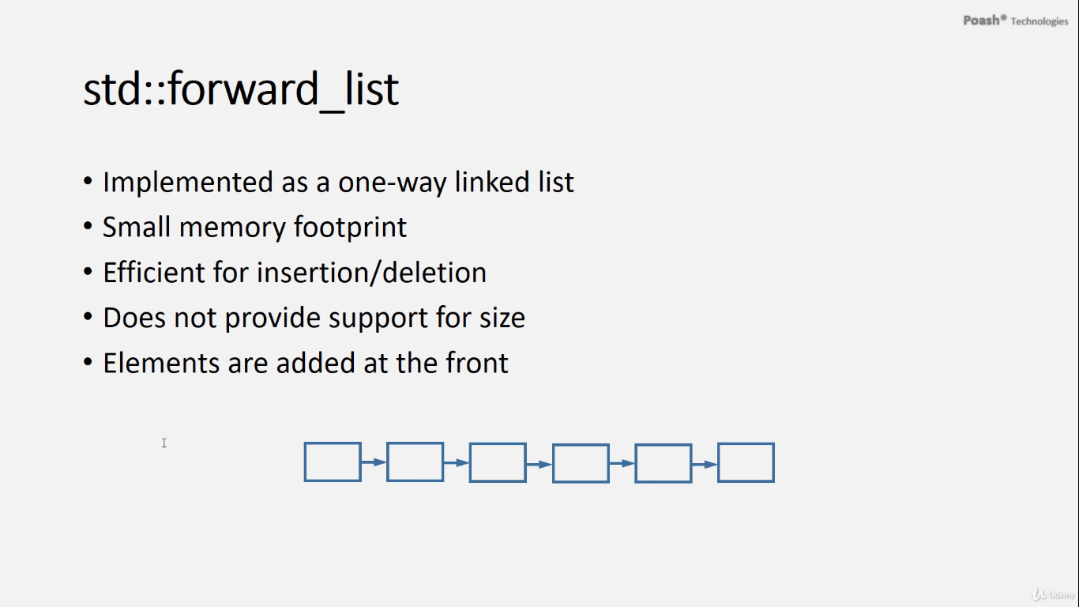

* The forward_list in C++ is a one-way linked list that allows traversal only in the forward direction. Unlike the double linked list, each node in a forward_list has only a forward pointer, which means you can traverse the list in one direction only. This characteristic makes the forward_list more memory-efficient compared to the double linked list.
* Forward_list was introduced in C++11 and is suitable when memory is a constraint and traversal in both directions is not required. It is particularly efficient for insertion and deletion operations anywhere in the list.
* However, forward_list does not provide support for accessing elements by index or size information. When elements are added to the forward_list, they are always added at the front. As a result, when you access the elements, you will retrieve them in the **reverse order** in which they were added to the list.
* Inserting and erasing elements in a forward list is slightly different compared to other containers. To insert an element inside the forward list, you use the function `**insert_after()`.** This function requires you to specify a position, as usual, along with the value of the element to be inserted. For example, **`insert_after()`** inserts a value of 10 at the second position, not the first.
* The reason for this behavior is that when you insert a new node with a value, such as 10, it only knows about the next node and not the previous one. Therefore, the node will be inserted after the node to which the iterator is pointing.
* Similarly, to erase an element from a forward list, you use the function **`erase_after()`.** This function removes the element following the specified iterator, rather than the element at the iterator itself. For example, **`erase_after()`** will not erase the first element but will erase the second element in the list.
* Despite these differences, insert and erase operations in a forward list are as efficient as those in other containers. Therefore, you can perform insertions and deletions anywhere in the forward list, as long as you have the iterator pointing to the desired location.

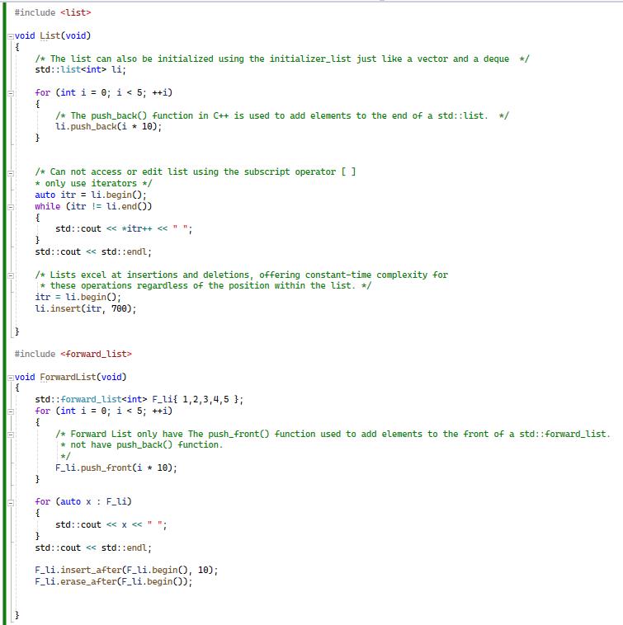

# Associative Container

# stdset & stdmultiset

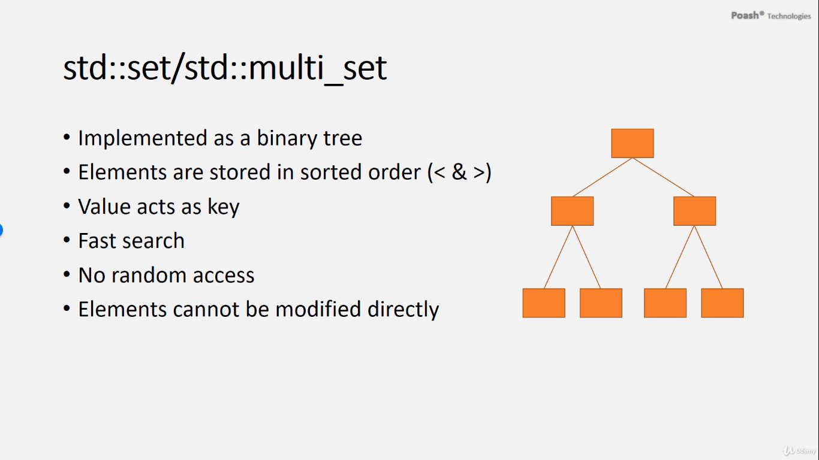

* A set and a multiset are two types of associative containers in C++. A set is implemented internally as a binary tree, which ensures that elements are **always stored in sorted order**. This sorting is done using comparison operators like **"less than" and "greater than".** In a set, the value itself acts as the key for sorting purposes.
* Sets provide fast **search and lookup operations** due to their underlying **binary tree** structure. However, sets do **not support random access** to elements. Additionally, once elements are inserted into a set, they cannot be directly modified.
* A multiset, on the other hand, is similar to a set but allows **duplicate** elements to be stored. Like sets, multiset elements are also stored in sorted order based on their values.
* Overall, sets and multisets are useful for maintaining **sorted collections of elements** while providing **efficient search and lookup operations**.

**Insert element:**

* **std::set**, elements are added using the **insert()** function instead of **push_back()** or **push_front()** like in sequential containers such as vectors or lists. The **insert()** function is used to add elements to the set while maintaining the sorted order defined by the **comparator**.
* To access the elements in a **std::set**, you typically use iterators. You can obtain iterators using functions like **begin()** and **end()**, and then iterate over the set to access its elements.

**Iterators:**

* In **std::set**, the iterators returned by functions like **begin()** and **end()** are **constant iterators**. This means that you cannot modify the elements in the set directly through these iterators.

**For example, you cannot modify the value of an element using an iterator obtained from a std::set, like this:**

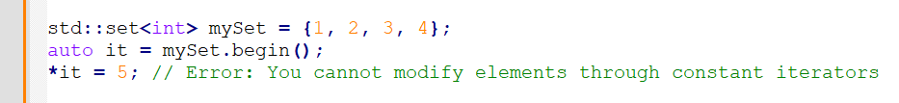Attempting to modify the elements through such iterators will result in a compilation error. If you need to modify the elements in a set, you would need to erase the existing element and insert a new one with the desired value.

* In C++, the **std::set** and **std::multiset** containers are implemented as binary search trees, where elements are ordered according to a strict weak ordering criterion. Due to the nature of these data structures and the requirements for maintaining the internal structure to ensure correct ordering and uniqueness (in case of **std::set**), the iterators returned by functions like **begin()** and **end()** for these containers are constant iterators.
* Constant iterators imply that you can iterate over the elements of the set or multiset, but you cannot modify the elements themselves. This restriction is essential for maintaining the internal structure of the set or multiset, as modifying elements could potentially violate the ordering properties or uniqueness constraints of these containers.
* By providing constant iterators, the C++ standard library ensures that users can safely iterate over the elements of **std::set** and **std::multiset** without inadvertently causing undefined behavior by modifying the elements. If you need to modify elements in a set or multiset, you would need to erase the element and then insert the modified version.
* In summary, the use of constant iterators in sets and multisets is a design choice that ensures the integrity and correctness of these associative containers, particularly with respect to their ordered and unique properties.

**Erase Elements**

* **std::set**, you can use the **erase()** function to remove elements from the set. It is overloaded to accept either a value or an iterator.
* If you want to erase elements based on their value, you can pass the value to the **erase()** function. This value acts as the key, as elements in a set are sorted based on their values.
* Alternatively, you can use iterators to specify the position of the element you want to erase. When using iterators, you pass the iterator pointing to the element you want to erase to the **erase()** function.

**Order of sorting of that:**

* the default ordering for elements in a set is ascending order, facilitated by the **std::less** comparator. This comparator uses the **<** operator internally. However, if you need to sort elements in descending order, you can utilize the **std::greater** comparator, which internally employs the **>** operator. Both **std::less** and **std::greater** are function objects defined in the **<functional>** header. By specifying **std::greater** as the comparator, you can achieve descending order in a set.

**Duplication:**

* In a standard set, duplicate elements are automatically removed upon insertion, meaning each element in the set is unique. However, in a multi-set, duplicates are permitted, allowing multiple occurrences of the same element. Therefore, while a set ensures uniqueness among its elements, a multi-set allows for duplicate elements to be stored.

**To search for a value in a multiset** and retrieve all its occurrences, you can use the **equal_range** function. Here's how it works:

1. **Call equal_range:** Use the **equal_range** function, passing the value you want to search for as the argument. For example, if you want to search for the value **3**, you would call **equal_range(3)**.
2. **Retrieve the result:** **equal_range** returns a **pair** object containing two iterators:

* The first iterator points to the first occurrence of the searched value.
* The second iterator points to the position immediately after the last occurrence of the searched value.

1. **Iterate over the occurrences:** You can then iterate over the range defined by these iterators to access all occurrences of the searched value.

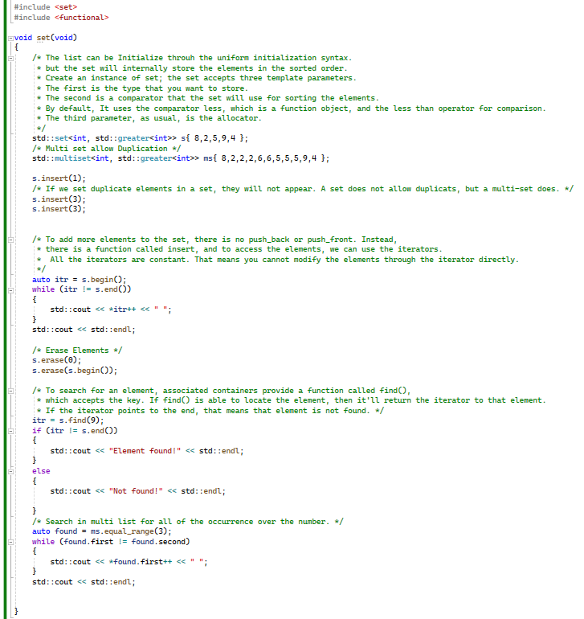

# stdmap & stdmultimap

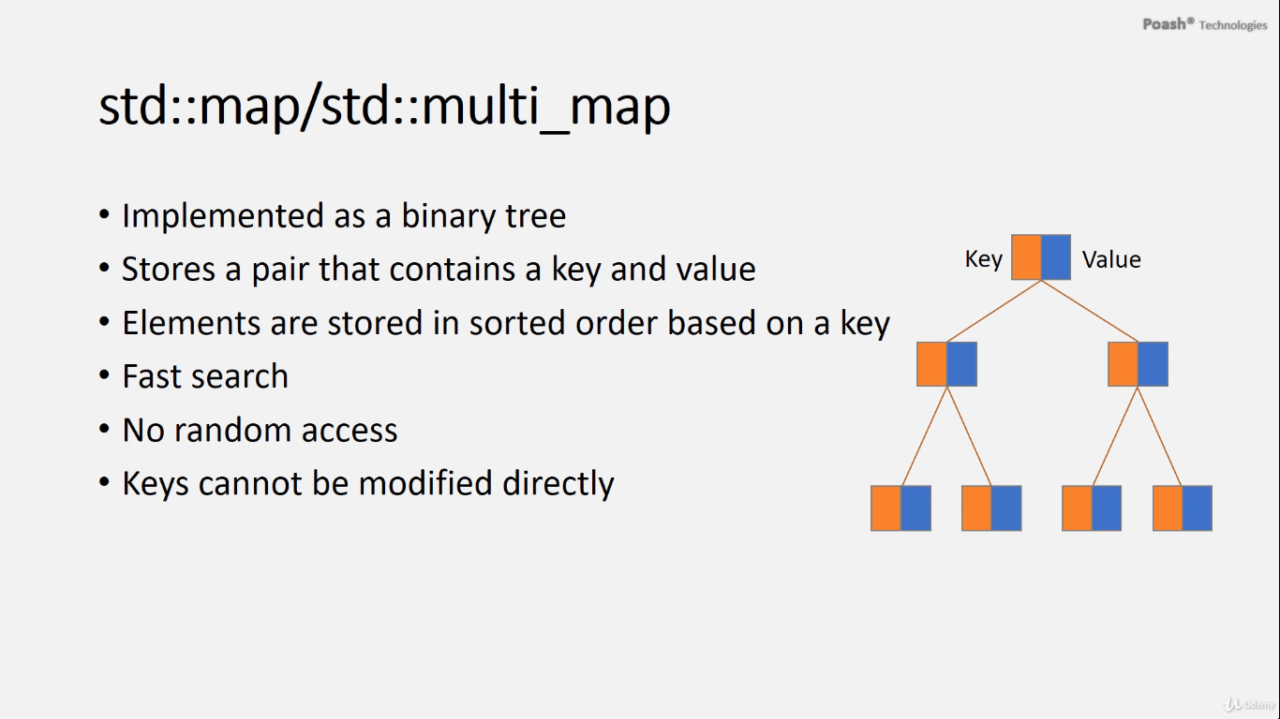  
The associative containers **map** and **multimap** in C++ are implemented as binary trees. Here's an overview of their characteristics:

1. **Map vs. Multimap:**

* **Map:** It stores unique key-value pairs where each key is unique. Keys are sorted based on their natural order or using a custom comparator function if provided.
* **Multimap:** It allows duplicate keys and stores key-value pairs. Keys are sorted similarly to maps.

1. **Key-Value Pairs:**

* Each element in the map or multimap is a pair object containing a key and a value.
* The elements are stored in sorted order based on the keys.

1. **Fast Search and Lookup:**
   * Both **map** and **multimap** provide efficient search and lookup operations due to their underlying binary tree structure.
2. **Random Access:**
   * Neither **map** nor **multimap** provides direct random access to elements. Instead, you must access elements through iterators or specific lookup methods.
3. **Modifying Keys and Values:**

* Keys in the map **cannot** be directly modified after insertion because doing so would violate the sorting order. However, values associated with keys can be modified.
* In a multimap, both keys and values can be modified.

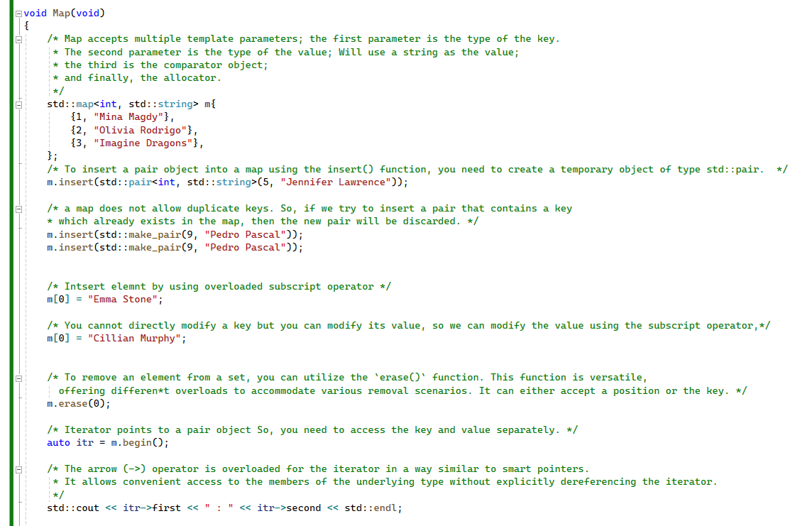

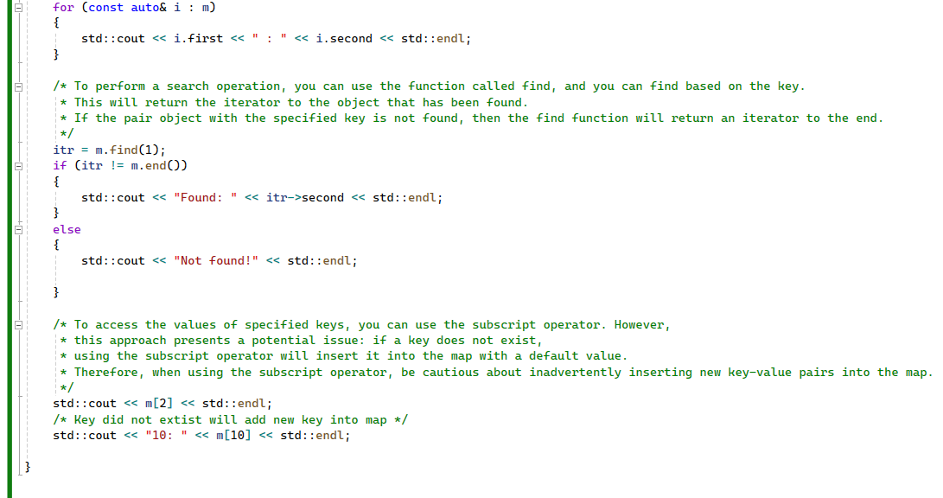

# Multi map

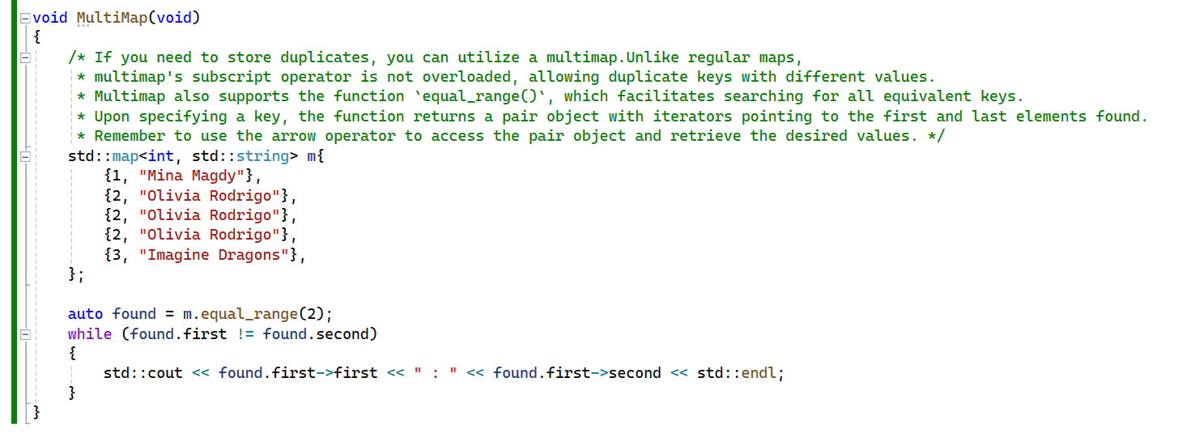

# Unordered Containers

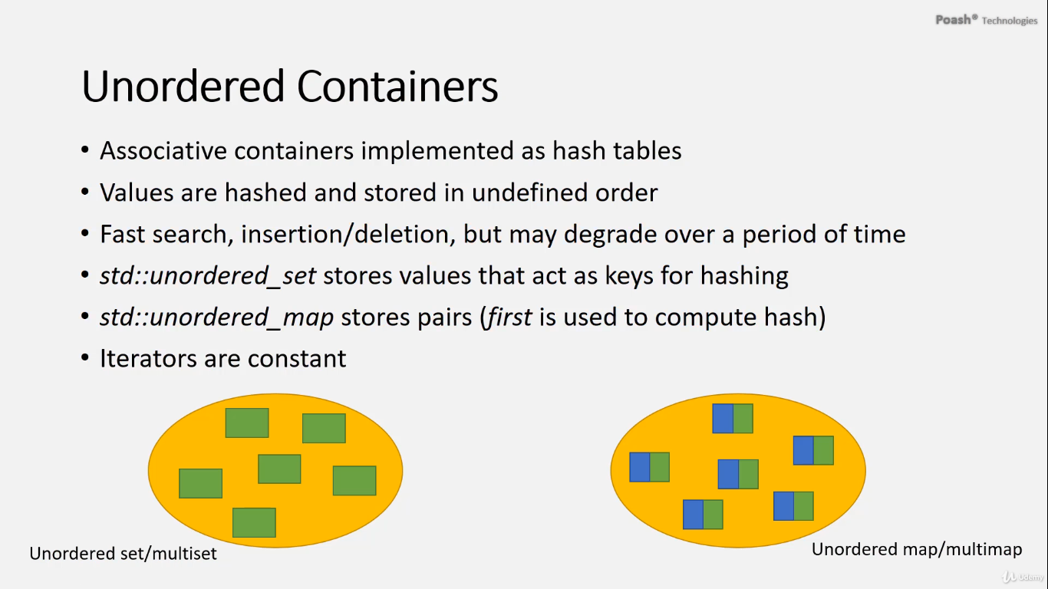

The characteristics and functionality of unordered containers in C++. Key points include:

* **Internal Implementation**: Unordered containers are implemented as hash tables, where values are hashed to determine their storage location within the container. However, the elements are not stored in a defined order.
* **Types of Unordered Containers**: There are two main types:
  + **Unordered set**: Stores unique values that serve as keys for hashing.
  + **Unordered map**: Stores key-value pairs, where the key part is used to compute the hash.
* **Efficient Operations**: Unordered containers offer efficient support for operations like search, insertion, and deletion. However, the performance of these operations may degrade over time.
* **Iterator Characteristics**: Iterators in unordered containers are constant, meaning they cannot be used to modify the stored values directly.

Overall, unordered containers provide a flexible and efficient way to store and manipulate data, particularly **when the order of elements is not critical.**

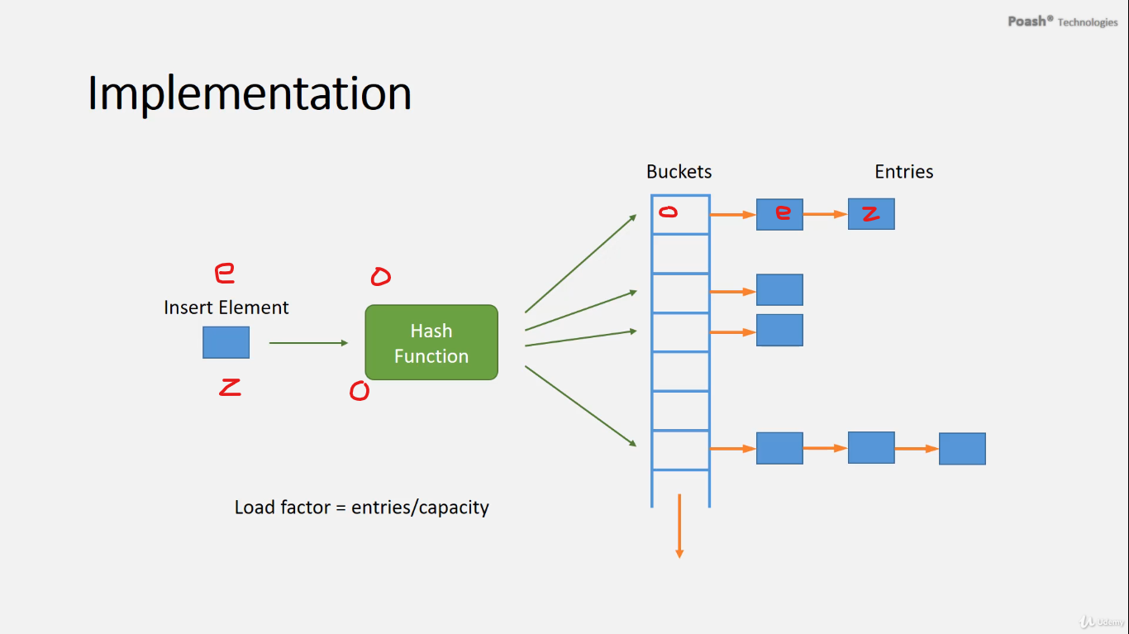

This overview provides insights into how collisions are managed in hash table implementations:

1. **Simple Setup**: Hash tables typically consist of a dynamic array where each position, called a bucket or slot, stores elements based on their computed hash value.
2. **Collision Handling**: When multiple elements hash to the same index, collisions occur. Various strategies are employed to manage collisions:
   * Some implementations store colliding elements in alternative positions within the hash table.
   * Many implementations utilize buckets, which contain pointers to linked lists. Each node in these lists represents an element hashed to the same index, allowing multiple elements to coexist at the same location.
3. **Performance Impact**: Excessive collisions can degrade hash table performance, as operations such as search and insertion may require traversing linked lists within buckets, resulting in slower performance.
4. **Load Factor**: The load factor, representing the ratio of entries to capacity in the hash table, is crucial. When the load factor surpasses a predefined threshold, the hash table undergoes resizing. This process involves rehashing elements to new positions, ensuring efficient performance by mitigating excessive collisions.

Overall, collision handling and resizing strategies play vital roles in maintaining the efficiency and performance of hash table implementations, with specific approaches varying based on the implementation's requirements and design.

The **std::unordered_set** template accepts four template parameters:

1. **Type of the Element**: This parameter specifies the type of elements that the **unordered_set** will store.
2. **Type of the Hash Function**: The hash function is used to compute the hash value of elements in the set. It determines the distribution of elements across the buckets of the hash table.
3. **Equality Operator**: This parameter specifies the equality comparison function used to compare elements for equality. It determines whether two elements are considered equal within the set.
4. **Allocator**: As usual with standard containers, the allocator parameter allows customization of the memory allocation strategy used by the **unordered_set**.

These template parameters provide flexibility and customization options for the **unordered_set** container. They allow users to define custom hash functions and equality operators tailored to their specific needs.

In the **unordered_map** template, the parameters are as follows:

1. **The first template parameter:** specifies the type of the key.
2. **The second template parameter:** specifies the type of the value.
3. **The third template parameter:** specifies the type of the hash function.
4. **The fourth template parameter:** specifies the type of the function object that uses the equality operator to compare keys.
5. **The fifth template parameter:** specifies the allocator.

* When the number of entries in the buckets of a hash table becomes too high, it leads to degraded performance. This degradation affects operations such as search, insert, and delete. As the number of entries increases, the hash table becomes less efficient in handling collisions, resulting in longer search times and slower insertion and deletion operations. Therefore, maintaining a balanced load factor is crucial for optimal performance in hash tables.
* When additional elements are added to the hash table and its capacity needs to be increased, the hash table undergoes a process called re-hashing. During re-hashing, all elements are rehashed to accommodate the increased capacity.
* For example, if the initial hash table has a capacity of 8 and contains 8 elements, resulting in a load factor of 1, adding one more element triggers re-hashing. After re-hashing, the capacity may increase, such as to 64, while the number of elements remains the same or increases.
* Despite re-hashing, there may still be instances where multiple entries are stored in the same bucket, as seen in bucket number 40 containing two entries. However, even with multiple entries in the same bucket, the performance of the unordered set for searches remains significantly better than that of associative containers like set.

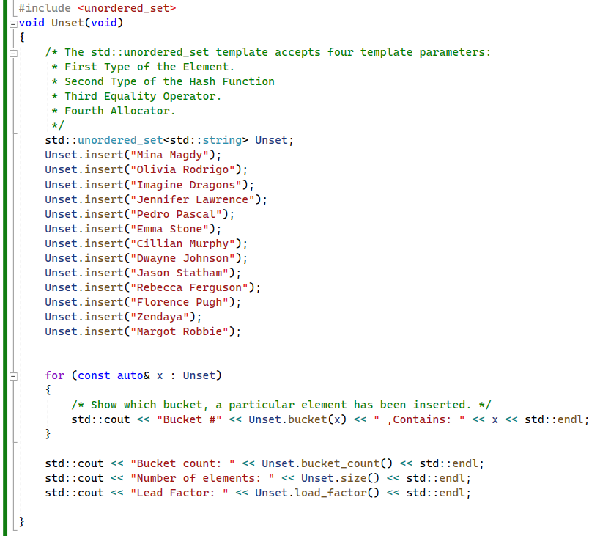

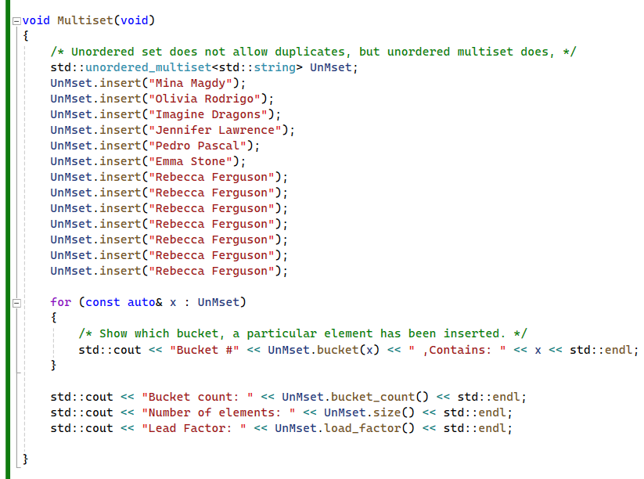

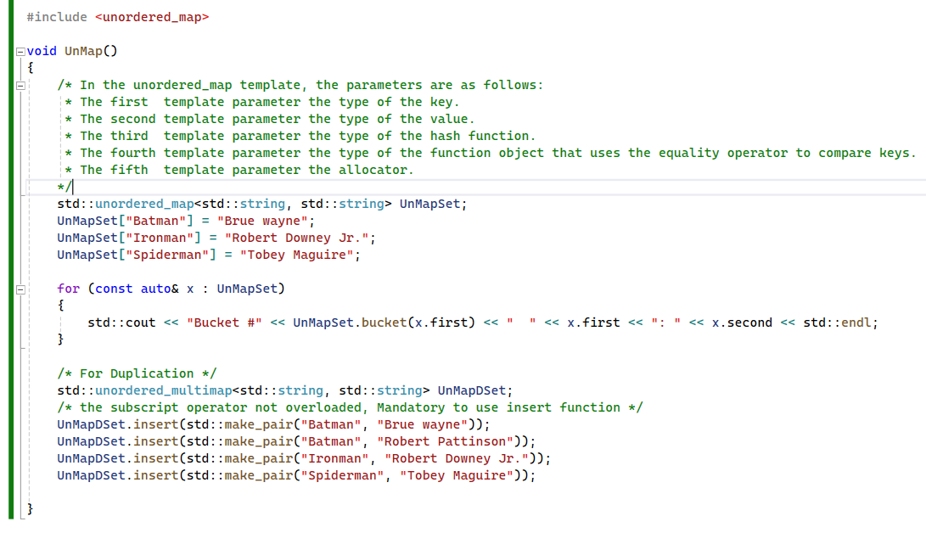

In C++, unordered containers like **std::unordered_set**, **std::unordered_map**, **std::unordered_multiset**, and **std::unordered_multimap** use hash tables for fast access to elements. These containers provide member functions to retrieve information about their internal structure. Here's a brief explanation of each function you mentioned:

1. **bucket_count()**: This function returns the number of buckets in the unordered container. Buckets are the internal data structures used to store elements based on their hash values. A larger number of buckets generally results in fewer collisions and better performance.
2. **bucket()**: This function takes a key or an iterator to an element and returns the index of the bucket where the element with that key is located. This can be useful for debugging or analyzing the distribution of elements in the hash table.
3. **size()**: This function returns the number of elements stored in the unordered container. It's a measure of the container's size in terms of the number of elements it contains.
4. **load_factor()**: The load factor is a measure of how full the hash table is. It's calculated as the ratio of the number of elements stored in the container to the number of buckets (**size() / bucket_count()**). A higher load factor generally indicates that the hash table is more densely populated, which can lead to more collisions and potentially slower performance. However, a small load factor may also result in wasted memory.

These functions provide insights into the internal structure and performance characteristics of unordered containers, allowing developers to make informed decisions about their usage and optimization.

# std::make_pair

**std::make_pair** is a utility function provided by the C++ Standard Library to construct a **std::pair** object conveniently. It's commonly used when you want to create a pair without explicitly specifying the types of its elements. Here's how it works:

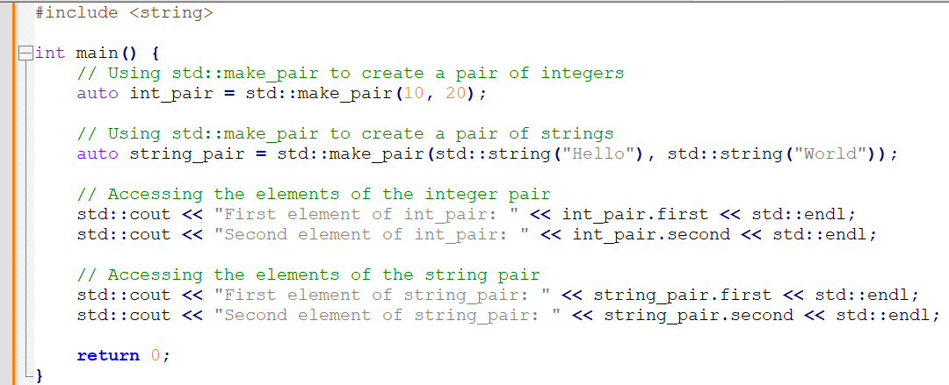

Here's an explanation of **std::make_pair**:

1. **Convenience**: **std::make_pair** provides a convenient way to create a pair without explicitly specifying the types. It deduces the types of the pair elements from the types of the arguments passed to it.
2. **Template Function**: **std::make_pair** is a function template, meaning it's parameterized by one or more types. It can be used to create pairs of different types.
3. **Automatic Type Deduction**: The types of the pair elements are deduced from the types of the arguments passed to **std::make_pair**. This makes the code more concise and less error-prone.
4. **Return Value**: **std::make_pair** returns a **std::pair** object initialized with the specified elements.

Overall, **std::make_pair** is a handy utility for creating pairs in C++, especially when dealing with templates or when you want to avoid explicitly specifying the types of the pair elements.

# Hash

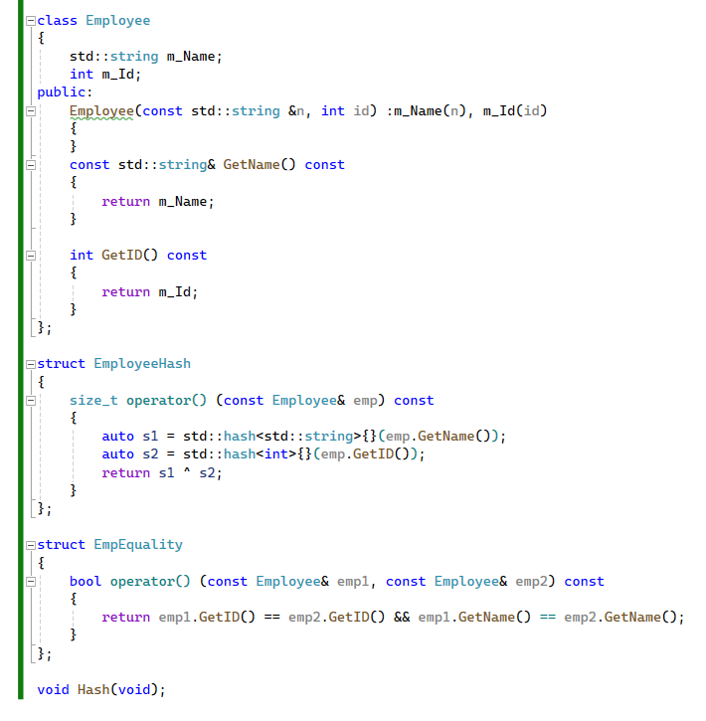

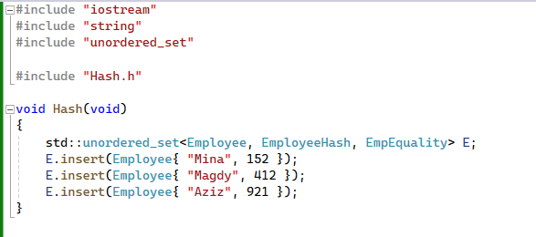

Implementing custom hash and equality function objects for user-defined types, such as the **Employee** class, in C++ involves several steps to ensure proper functionality within containers like **unordered_set**. Let's outline the process:

1. **Understanding the Role of the Hash Class**:
   * The **hash** class in C++ provides hash functionality for various types.
   * It is already specialized for different types, including strings.
   * Hashes are computed using the function call operator of the **hash** class.
2. **Defining the Employee Class**:
   * Define the **Employee** class with relevant attributes, such as **name** and **ID**.
   * Overload comparison operators (**<**, **>**, **!=**, **==**) for the **Employee** class to enable their internal usage by containers.
3. **Creating Custom Function Objects**:
   * Create a custom function object for hashing, which combines hashes of attributes.
   * Provide getters for attributes to facilitate hash computation.
   * Implement another function object for equality operations, ensuring it compares all attributes used in the hash function.
4. **Ensuring Consistency**:
   * Ensure consistency between the equality implementation and the hash function for the **Employee** class.
   * Consistent implementations ensure correct behavior within containers.
5. **Usage in Containers**:
   * Utilize the custom function objects within containers like **unordered_set**.
   * Add values to the container using the custom hash function.
   * Retrieve values from the container, ensuring proper equality comparisons.
6. **Optimization Suggestions**:
   * Optimize hash function implementations for better performance.
   * Consider using **hash_combine** from the Boost Library for improved results.
7. **Importance of Comprehensive Equality Implementation**:
   * Emphasize the significance of comprehensive equality implementation.
   * Ensure all attributes used in the hash function are compared for accurate equality checks.

By following these steps, developers can effectively implement custom hash and equality function objects for user-defined types in C++, ensuring proper functionality within containers and optimizing performance where possible

# The equality operator

The equality operator (**operator==**) is not inherently mandatory for user-defined types when using an **std::unordered_set** in C++. However, it becomes necessary for the correct behavior of the unordered set when it needs to compare elements for equality.

Here's why defining an equality operator is important for user-defined types used in an unordered set:

1. **Hashing Function Requirement:** **std::unordered_set** uses a hash table internally to store its elements. Each element is mapped to a unique bucket based on its hash value. To determine the bucket for an element, the container requires a hash function (**std::hash**). While the hash function maps elements to hash values, it does not guarantee uniqueness. Elements with different values may produce the same hash value. In such cases, the equality operator is used to confirm whether two elements are truly equal or if it's a hash collision.
2. **Equality Comparison during Lookup:** When you perform operations like **find()** or **count()** on an **std::unordered_set**, the container needs to compare elements to determine if the element being searched for matches any existing element in the set. This comparison is done using the equality operator.
3. **Equality for Insertion:** When inserting elements into an **std::unordered_set**, the container needs to ensure that no duplicate elements are added. Again, the equality operator is used to compare elements to check for duplicates.

For user-defined types, the default equality operator provided by the standard library may not be suitable or may not exist. In such cases, it's the responsibility of the user to define their own equality operator (**operator==**) for the type. This allows the unordered set to correctly compare elements of the user-defined type for equality and ensure the proper functioning of operations like insertion and lookup.

# The hash operator

The hash operator (also known as the hash function) is mandatory for user-defined types when using an **std::unordered_set** in C++. Here's why:

1. **Hash Table Requirement:** **std::unordered_set** internally uses a hash table data structure to store its elements. Each element is mapped to a unique bucket based on its hash value. The hash function calculates this hash value for each element.
2. **Efficient Lookup:** The purpose of using a hash table is to provide efficient lookup operations. Given an element, the hash function computes its hash value, allowing the container to quickly determine which bucket contains the element (or if it exists in the set at all). This results in constant-time complexity for operations like insertion, deletion, and search, on average.
3. **Hash Function Requirement:** To achieve the benefits of constant-time complexity, the hash function used must be well-defined and deterministic. It must consistently produce the same hash value for the same input element. This ensures that elements with equal values are consistently mapped to the same bucket.
4. **Equal Hash Values for Equal Elements:** Additionally, the hash function should strive to distribute elements evenly across the available buckets to minimize collisions (where different elements produce the same hash value). However, hash collisions are inevitable. The equality operator (**operator==**) is then used to distinguish between elements that have the same hash value but are not equal.

For user-defined types, the standard library may not provide a suitable hash function out of the box. Therefore, it's the responsibility of the user to define a custom hash function for their type. This custom hash function should adhere to the requirements mentioned above, ensuring that it produces consistent and well-distributed hash values for elements of the user-defined type.

# Big O Notation & Performance of Containers

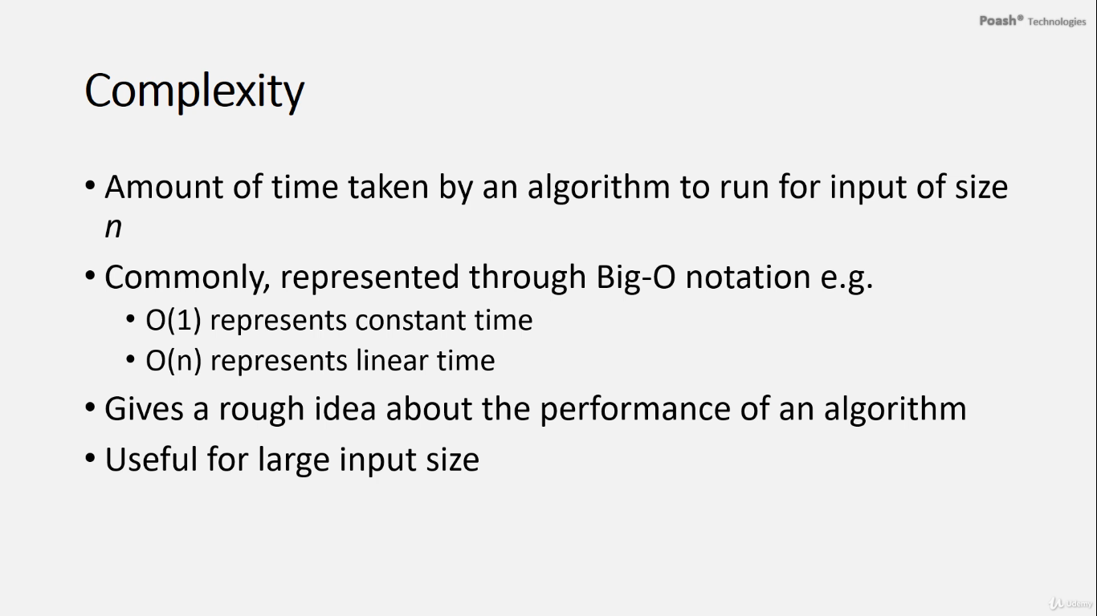

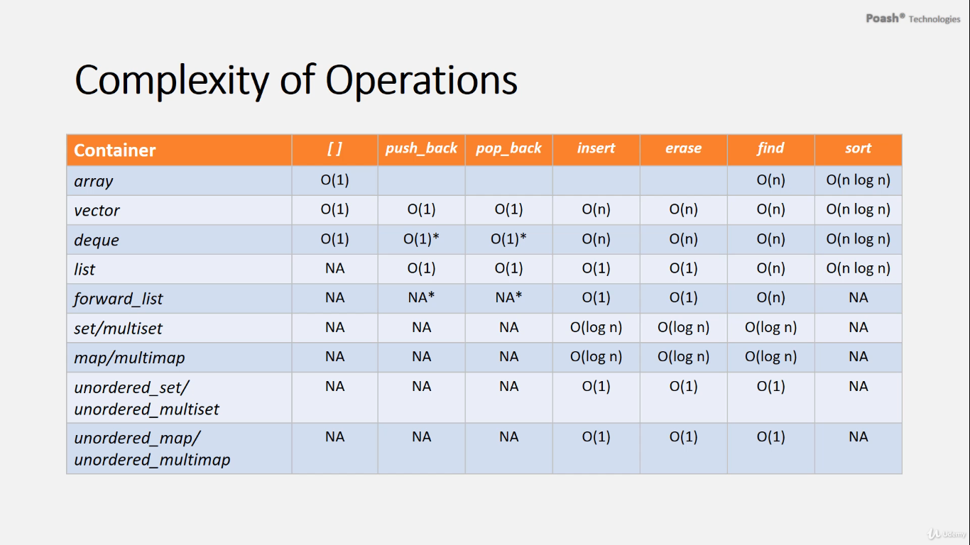

# Summary And main difference between containers types

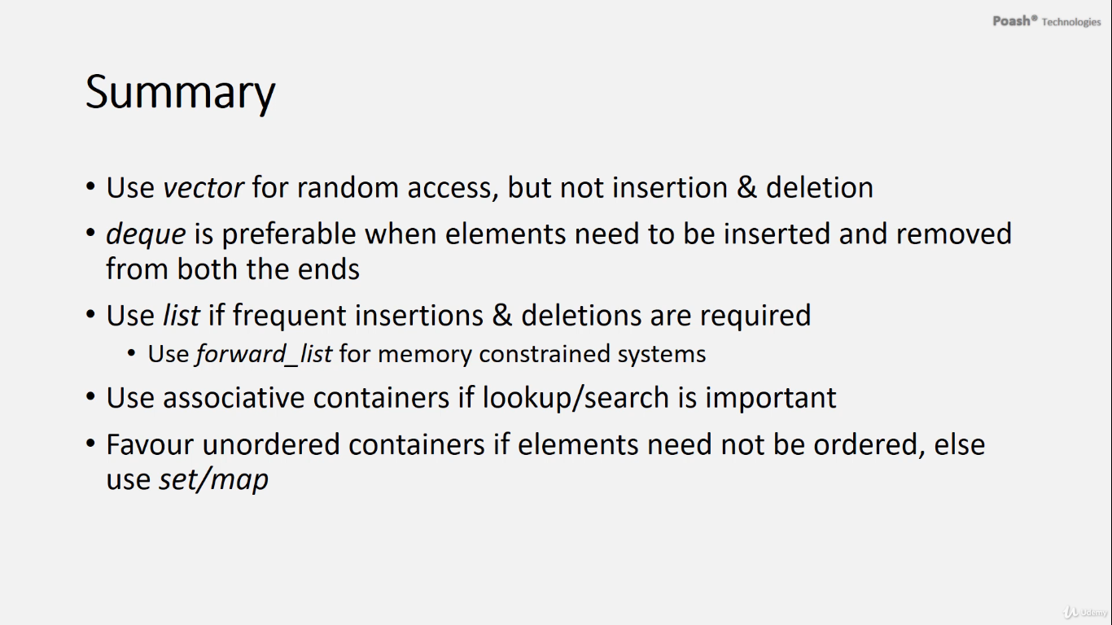



the standard library in C++ provides various container types categorized into three main groups:

A. **Sequence Containers**:

1. **Array**: A fixed-size sequence container.
2. **Vector**: A dynamically resizable array.
3. **List**: A doubly linked list.
4. **Deque**: A double-ended queue.
5. **Forward List**: A singly linked list.

B. **Associative Containers**:

1. **Set, Multiset**: Containers that store unique keys in sorted order. Set stores unique keys, while multiset allows duplicate keys.
2. **Map, Multimap**: Containers that store key-value pairs in sorted order. Map stores unique keys, while multimap allows duplicate keys.

C. **Unordered Containers**:

1. **Unordered Set, Unordered Multiset**: Containers that store unique keys, implemented using hash tables for fast retrieval. Unordered set stores unique keys, while unordered multiset allows duplicate keys.
2. **Unordered Map, Unordered Multimap**: Containers that store key-value pairs, implemented using hash tables for fast retrieval. Unordered map stores unique keys, while unordered multimap allows duplicate keys.

These containers offer different trade-offs in terms of performance, memory usage, and the operations they support, allowing developers to choose the most suitable one based on their specific requirements.

**The main difference between map and set in C++ is how they store and organize elements:**

1. **Set**:

* A **set** is a container that stores unique elements in a sorted order.
* Elements in a set are stored based on their values.
* Each element in a set must be unique; duplicate elements are not allowed.
* Internally, a set is usually implemented as a balanced binary search tree (like a Red-Black Tree), which ensures logarithmic time complexity for most operations like insertion, deletion, and search.
* Examples: **std::set**, **std::unordered_set**.

1. **Map**:

* A **map** is a container that stores key-value pairs in a sorted order based on the keys.
* Each element in a map consists of a key and an associated value.
* Keys in a map must be unique, but different keys can be associated with the same value.
* Internally, a map is typically implemented as a balanced binary search tree, similar to a set, but each node contains both a key and a value.
* Examples: **std::map**, **std::unordered_map**.

In summary, while both **map** and **set** store elements in sorted order, a **set** stores individual elements, while a **map** stores key-value pairs. The choice between them depends on whether you need to associate values with keys or simply store unique elements.

**The decision between using a std::map and a std::set depends:**

Use **std::map** when:

1. **Associating Values with Keys:** If you need to associate a value with each key, a map is the appropriate choice. For example, if you are building a dictionary where each word (key) is associated with its definition (value), **std::map** would be suitable.
2. **Key-Based Operations:** When you need to perform operations based on keys, such as searching for a value using a key, inserting key-value pairs, or removing key-value pairs, **std::map** provides efficient key-based operations.

Use **std::set** when:

1. **Maintaining a Sorted Collection of Unique Elements:** If you only need to maintain a sorted collection of unique elements without associated values, a set is more appropriate. It ensures that elements are stored in sorted order and duplicates are automatically removed.
2. **Element-Based Operations:** When you need to perform operations based on elements, such as checking for the presence of an element, inserting elements, or removing elements, **std::set** provides efficient element-based operations.

In summary, choose **std::map** when you need to associate values with keys and perform key-based operations, and choose **std::set** when you only need to maintain a sorted collection of unique elements and perform element-based operations.

The decision between using Associative Containers (like **std::map**, **std::set**, etc.) and Unordered Containers (like **std::unordered_map**, **std::unordered_set**, etc.) depends on the specific requirements and constraints of your application. Here are some considerations for each:

**Associative Containers:**

1. **Ordered Collection:** Associative containers maintain elements in a sorted order based on some criteria, typically the key. If you need to keep your data sorted and accessible in a specific order, associative containers are suitable.
2. **Efficient Search:** Associative containers provide efficient search operations (**find**, **lower_bound**, **upper_bound**, etc.) because elements are stored in a sorted manner, allowing for logarithmic time complexity for search operations.
3. **Balanced Trees:** Internally, associative containers like **std::map** and **std::set** typically use balanced binary search trees (like Red-Black trees) to maintain their ordering, ensuring efficient insertion, deletion, and search operations in most cases.

**Unordered Containers:**

1. **Hash-Based Storage:** Unordered containers use hash tables internally, which offer constant time complexity (**O(1)**) for average-case insertion, deletion, and search operations. This makes them particularly efficient for large datasets.
2. **No Guaranteed Order:** Unlike associative containers, unordered containers do not guarantee any specific order of elements. Elements are stored based on their hash values, and the ordering may vary depending on the implementation and hash function.
3. **Hash Function Dependency:** The performance of unordered containers depends heavily on the quality of the hash function provided for the key type. A good hash function distributes elements evenly across the hash table, minimizing collisions and maximizing performance.

**When to Use Each:**

* **Associative Containers:** Use when you need to maintain elements in a specific order (sorted), or when you require efficient ordered traversal of elements. They are also suitable when you need to perform range queries (e.g., finding elements within a range).
* **Unordered Containers:** Use when you prioritize fast insertion, deletion, and search operations over maintaining a specific order of elements. Unordered containers are particularly useful for tasks like membership testing (checking if an element exists in a set) and when the order of elements is not relevant.

In summary, choose associative containers when order matters and efficient ordered traversal is required, and choose unordered containers when you prioritize fast lookup operations and don't need to maintain a specific order of elements.

Let's discuss the advantages and disadvantages of using an unordered set compared to an unordered map:

1. **Unordered Set**:
   * **Advantages**:
     + Efficient storage: An unordered set stores unique contacts efficiently without the need for keys, which can reduce overhead.
     + Fast membership check: Checking if a contact exists in the set is fast and efficient.
     + Simplified implementation: Managing unique contacts without keys can simplify the implementation compared to using a map.
   * **Disadvantages**:
     + Limited lookup capabilities: While you can efficiently check if a contact exists in the set, you cannot directly access contacts by attributes such as first name or last name. This means you'll need to iterate over the entire set to find a specific contact, resulting in slower lookup compared to a map.
     + Limited flexibility: If you need to associate additional data with contacts or perform more complex queries, an unordered set may not provide enough flexibility compared to a map.

**When to use an unordered set over an unordered map:**

* Use an unordered set when you only need to store unique contacts and perform membership checks without the need for direct access or additional data association.
* If your application primarily focuses on checking if a contact exists in the set or performing operations that don't require attribute-based lookup, an unordered set can be a suitable choice.
* Consider using an unordered set when simplicity and efficient storage are more important than lookup speed or additional functionality.

Ultimately, the choice between an unordered set and an unordered map depends on the specific requirements and constraints of your application. You should evaluate these factors to determine which data structure best fits your needs.

**When to use an unordered map over an unordered set:**

* **Key-Value Association**: Use unordered map when you need to associate additional data with contacts, such as unique identifiers or keys.
* **Complex Queries**: Unordered map is preferable for complex queries or operations beyond simple membership checks, enabling efficient retrieval based on specific attributes.
* **Efficient Lookup**: If frequent attribute-based lookup is required, unordered map provides faster retrieval compared to unordered set by allowing direct access based on keys.
* **Data Integrity**: Consider using unordered map when maintaining data integrity and consistency is crucial, especially for scenarios involving multiple attributes that need to be updated together.

In essence, use unordered map over unordered set when you need key-value association, efficient attribute-based lookup, support for complex operations, or when data integrity and consistency are paramount.

The relationship between the default constructor and using the subscript operator (**[]**) in C++ lies in how the standard library containers, like **std::unordered_map**, manage their elements.

Here's how it works:

1. **Subscript Operator ([])**:
   * When you use the **[]** operator to access or insert an element into a map, the map tries to find the element corresponding to the provided key.
   * If the key is found, it returns a reference to the value associated with that key.
   * If the key is not found, it inserts a new element with that key and returns a reference to the value of the newly inserted element.
2. **Default Constructor**:
   * A default constructor is a constructor that can be called without any arguments.
   * When a new element is inserted into a map using the **[]** operator and the key does not exist, the map needs to create a new value for that key.
   * This creation of a new value typically involves calling the default constructor of the value type to initialize the new value.

So, if the value type used in the map does not have a default constructor, the compiler cannot create a new value when inserting a new element using the **[]** operator, leading to a compilation error.

In your case, the **Contact** class does not have a default constructor. Therefore, when you attempt to insert a new **Contact** object into the map using the **[]** operator, the compiler encounters an error because it cannot create a new **Contact** object without arguments.

# Understanding Container Performance and Complexity

Before delving into the performance of different containers for various operations, it's crucial to grasp the concept of complexity. Complexity refers to the runtime taken by an algorithm to execute for an input of size n. This is typically denoted using Big-O notation, where O(1) represents constant time, implying that an operation takes the same amount of time regardless of the number of elements. Conversely, linear time operations, denoted as O(n), depend on the number of elements.

While Big-O notation provides a rough estimation of algorithm performance, it's particularly valuable for large input sizes. Now, let's explore the complexities of common operations across different containers.

**1. Random Access:**

* Random access, a constant time operation (O(1)), is only available in arrays, vectors, and deques. Other containers lack this capability.

**2. Push_Back:**

* Arrays, being static containers, lack the push_back operation. However, vectors, deques, and lists support this, each performing it in constant time.
* Deques also offer push_front, another constant time operation, as does forward_list.

**3. Pop_Back:**

* Pop_back, removing the last element of a container, is also a constant time operation present in vectors, deques, and lists but absent in associative containers.

**4. Insert and Erase:**

* These operations take linear time in vectors and deques due to element shifting. However, they're constant time in lists and forward_lists.
* For associative containers like set, multiset, map, and multimap, insert and erase operations take O(logn) time due to their binary tree implementation.

**5. Find Operation:**

* While linear time for sequence containers, the find operation in associative containers takes O(logn) time, and for unordered containers, it's constant time with a low load factor.

**6. Sorting:**

* Sorting operations, like sort, have complexities based on container types. Sequence containers support O(nlogn) time complexity, while unordered containers and forward_lists lack support due to their nature.

**Understanding these complexities aids in selecting the appropriate container for specific tasks. For instance:**

* Vector is suitable for random access but not for frequent insertion and deletion.
* Deque is preferable for end manipulation but not for mid-element operations.
* List is ideal for frequent insertions and deletions at any position.
* Forward_list conserves memory but lacks certain operations.
* Associative containers excel in lookup-heavy applications, while sets and maps are preferred for sorting.
* Unordered containers are optimal for search operations due to their superior performance.

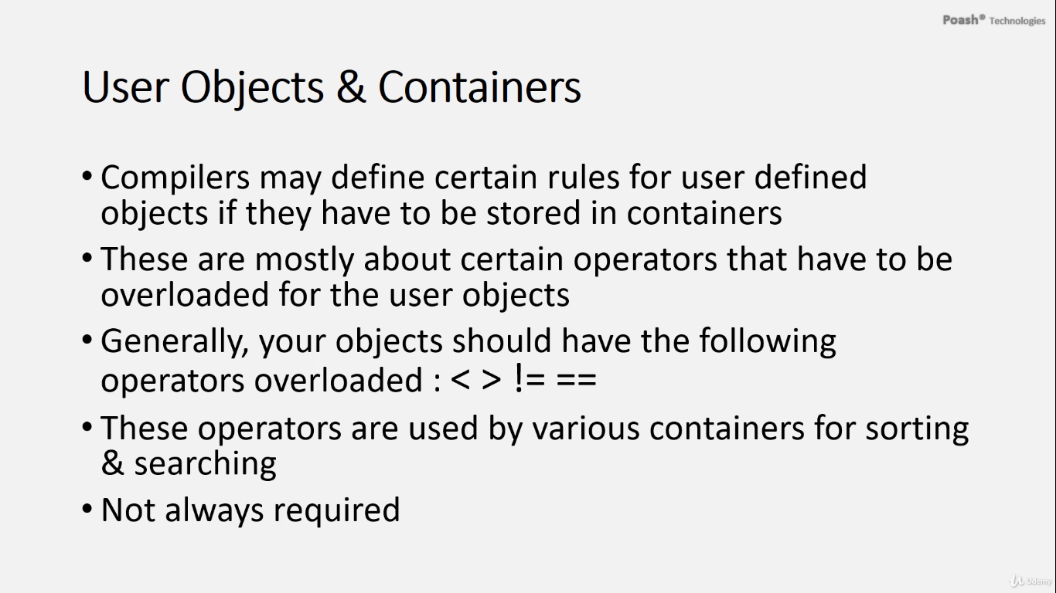

**Understanding Common Algorithms in STL**

* In exploring the Standard Template Library (STL), it's essential to comprehend both the containers and algorithms it offers. Containers serve as data holders, while algorithms represent the operations applicable to that data.
* When working with STL, it's common to store user-defined objects within containers. However, certain considerations arise in this scenario. Compiler vendors may impose rules for user-defined objects to be stored effectively in containers.
* These rules often revolve around overloading specific operators for user-defined objects. Typically, the operators requiring overloading include less than (<), greater than (>), not equal to (!=), and equal to (==). These operators are internally utilized by containers and algorithms, particularly for sorting and searching functionalities.
* Although overloading these operators might seem mandatory, it's worth noting that they aren't always necessary. Alternatively, one can achieve similar functionality by implementing a function object, offering flexibility in the design and usage of user-defined objects within STL containers.

# Algorithms

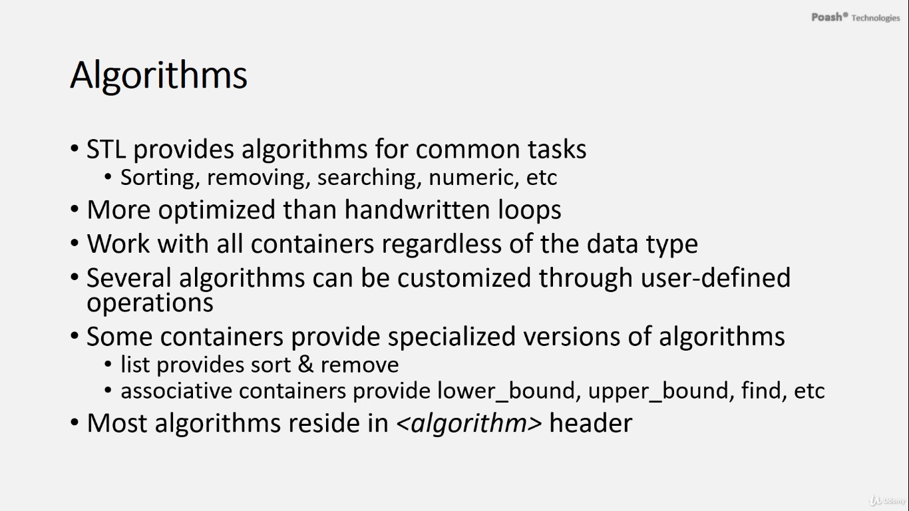

**Exploring STL Algorithms**

* Let's dive into the world of STL algorithms. These are tools provided by the Standard Template Library that help you manipulate your data in various ways.
* Think of them as pre-made actions you can apply to your data, **such as sorting it, removing items, or searching for specific elements.**
* What's great about these algorithms is that they're designed to be efficient and versatile. They work with all kinds of data containers, no matter what type of data you're working with.
* Even better, you can customize these algorithms to suit your specific needs. You can tweak them using **callbacks** or **function objects** to make them do exactly what you want.
* While the STL gives you a wide range of useful algorithms, some containers like lists have their own specialized versions of these tools. These are tailored to work particularly well with the way those containers store data, making them even more efficient.
* The same goes for containers like sets and maps. They have their own versions of essential actions like finding elements or determining where new items should be placed within the collection.
* And if you're wondering where to find these algorithms, they're all conveniently located in the **"algorithm"** header, making them easy to access and use in your code.

**Understanding Algorithm Arguments**

* When using algorithms in C++, it's important to remember that they typically require at least two arguments.
* The first argument is an iterator pointing to the beginning of the range of elements you want to operate on, and the second argument is an iterator pointing to the end of that range. Sometimes, there might be additional arguments needed depending on the specific algorithm.
* For example, let's take the **sort** algorithm. It only needs two arguments: the beginning and end iterators. By default, **sort** uses the "less than" operator (**<**) to compare elements, but if we haven't defined this operator for our custom class (let's say, **Employee**), the compiler will throw an error when we try to use **sort** with a collection of **Employee** objects.
* Similarly, if we try to create a **set** or **map** using **Employee** objects without defining the necessary comparison operators, we'll encounter similar compiler errors. For instance, if we attempt to use **sort** on a **set**, the compiler will complain about the absence of the necessary comparison operator.
* To fix this, if we're using an unordered container like **unordered_set**, we need to provide a hash function for our custom type (e.g., **Employee**). Additionally, we need to define the equality operator to enable the comparison of **Employee** objects inside the unordered container. This ensures that the container can properly manage and compare elements of our custom type.
* The operator function could be a global or a member function and it should be a constant member function.

1. **Overloaded constant member function "less than" operator to utilize by the algorithm:**

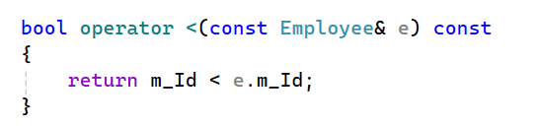

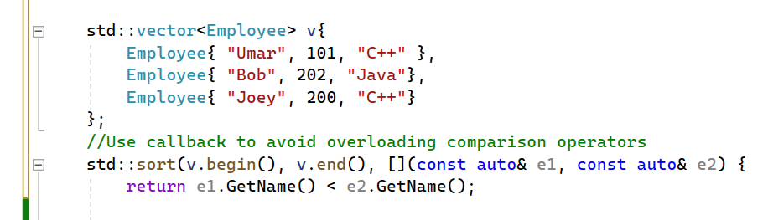

**Sorting Objects Based on Names with Callbacks**

* Once you've implemented the "less than" operator for your class, sorting objects based on names might be your next goal. However, you'll hit a snag because overloading the "less than" operator again isn't an option.
* But fear not! There's another version of the **sort** algorithm that comes to the rescue. This version allows you to pass in a callback function, known as a predicate. A predicate is simply a function that gives back either true or false.
* In this case, the predicate is a binary one, meaning it takes two arguments for comparison. Instead of crafting a separate function object, you can employ a lambda expression. This lambda lets you specify the comparison logic right within the **sort** call, bypassing the need to overload the "less than" operator again.
* With the lambda expression, you can precisely define how names should be compared during sorting, all without the hassle of additional operator overloads.
* So, if you're keen on sorting based on names, this is where you can make that happen.
* And here's the kicker: you don't always have to overload operators for your class. Especially not when you can tweak the algorithm using callbacks, as demonstrated here.

1. **Using lambda callbacks for the "less than" operator to utilize by the algorithm:**

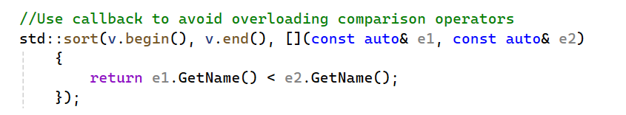

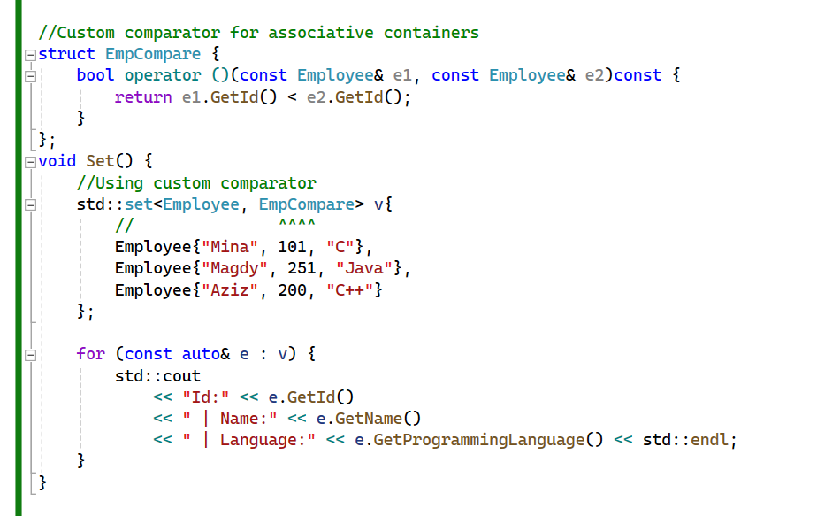

Let's store **Employee** objects in a set.

Upon compilation, it fails due to the absence of a less-than operator in the **Employee** class.

**There are two potential solutions:**

1. **Overload** the less-than operator.
2. **Create a function object** to handle comparison, offering more flexibility to choose attributes for comparison.

Let's proceed with the function object approach. We'll implement the function call operator, accepting two **Employee** objects, ensuring it's a constant member function, and comparing based on their IDs.

Now, let's specify this comparator as the second argument in the set. Upon building, it compiles successfully.

Upon execution, you'll observe the employees sorted based on their IDs.

* Similar steps can be followed for **multi_set**, **map**, and **multi_map**. For unordered containers, two actions are necessary:

1. Implement the **hash function**.
2. Implement the **function object handling comparison**.

# It's more convenient to access data in the container using algorithm.

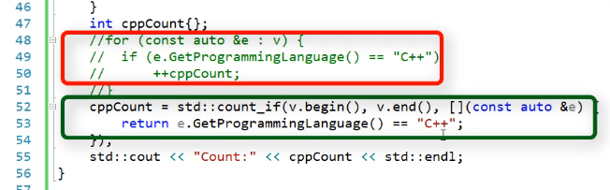

Assume we want to determine how many employees know C++.

* We could achieve this with a for loop, iterating through the employees and counting those with C++ skills. Upon execution, the count would correctly be 2.
* However, for a programmer reading this code, the purpose of the loop might not be immediately apparent. It requires scanning through the loop to understand its intent, which is to count employees with a specific language skill.
* Fortunately, the STL provides an alternative: the **count** algorithm. This function returns the count of specific elements in a container.
* We can use this algorithm instead. Its parameters include the iterator to the beginning, the iterator to the end, and the value to search for. However, since **count** uses the equality operator (**==**), which we haven't overloaded for our **Employee** class, it won't compile.

**To address this, we have two options:**

1. Overload the equality operator in our class.
2. Use **count_if**, another version of **count**, where the third parameter is a predicate, typically implemented with a lambda expression.

* Using **count_if** with a lambda expression to define the equality operator implementation, we achieve the same result with a more concise code. The count is still correctly reported as 2.
* This approach demonstrates the power of using algorithms with callbacks, offering flexibility without the need to overload operators in our class.
* Comparing the handwritten for loop with **count_if**, the latter leads to more readable and understandable code. The name of the algorithm clearly indicates its purpose, enhancing code clarity and maintainability. Therefore, it's advisable to prefer algorithms over handwritten loops whenever possible

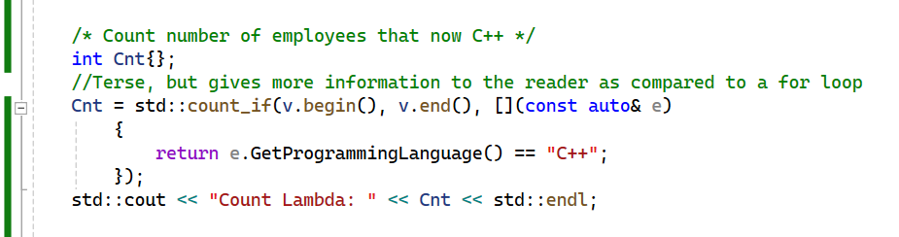

**Here's a breakdown of the code:**

* **Cnt** is initialized to 0.
* **std::count_if** is called with three arguments: **v.begin()** and **v.end()** specify the range of elements to be considered, and the lambda function defines the condition that each element must satisfy to be counted.
* The lambda function takes a reference to each element **e** and returns **true** if **e**'s programming language is "C++", and **false** otherwise.
* The result of **std::count_if** is stored in **Cnt**.
* Finally, the count is printed to the standard output using **std::cout**.

This approach allows you to count elements based on custom conditions specified in the lambda function. It's a concise and expressive way to achieve the desired functionality without the need for manual iteration through the container.

* **v.begin()** returns an iterator that points to the beginning of the container **v**. In C++, iterators are objects that behave like pointers and provide a way to access elements in a sequence (like arrays or containers) sequentially.
* When you call **v.begin()**, you get an iterator pointing to the first element of the container **v**. You can then use this iterator to traverse the elements of the container, access their values, and perform various operations.
* Similarly, **v.end()** returns an iterator pointing to the position just beyond the last element of the container **v**. It's often used to determine the end of the range when iterating over the container.
* In the context of algorithms like **std::count_if**, **v.begin()** and **v.end()** together specify the range of elements over which the algorithm should operate.

Using **std::find_if** is a more concise and expressive way to search for elements in a container based on a condition, rather than writing a handwritten loop.

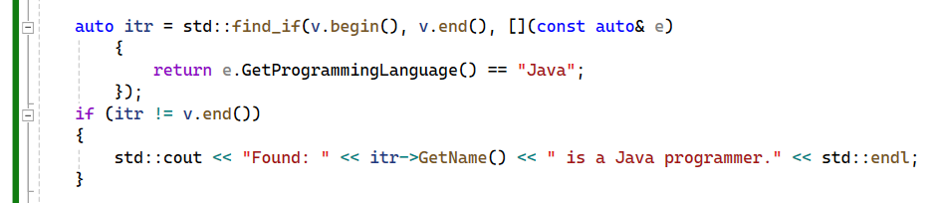

* **std::find_if** searches for an element in the range **[v.begin(), v.end())** that satisfies the condition specified by the lambda expression.
* The lambda expression captures the value **"Java"** from the surrounding scope and compares it with the programming language of each employee (**e.GetProgrammingLanguage()**).
* If **std::find_if** finds an element that satisfies the condition, it returns an iterator to that element. Otherwise, it returns **v.end()**, indicating that no element was found.

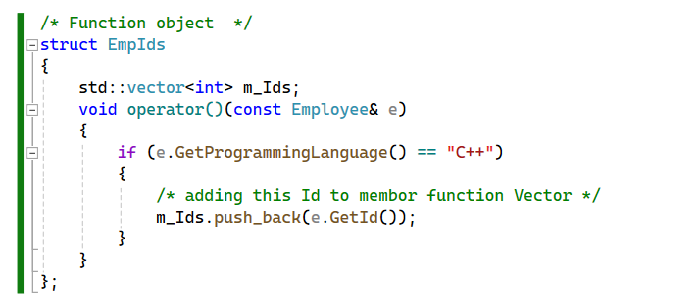

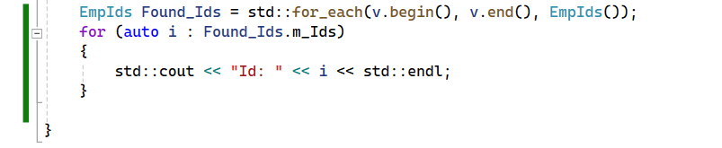

* This code iterates over the vector **v** using **std::for_each** and applies the **EmpIds** function object to each element. If an employee in the vector knows C++, their ID is added to the **m_Ids** vector within the **EmpIds** object. Finally, the IDs found are printed out using a range-based for loop.
* The **std::for_each** algorithm is a versatile tool in the C++ Standard Library that acts like a customizable for loop. It allows developers to execute specific actions on each element within a container by providing a callback function.
* A notable feature of **std::for_each** is its ability to return the provided callback function. This empowers developers to reuse the same callback function for subsequent operations or analysis, enhancing code reusability.
* For instance, let's say we want to extract the IDs of all C++ programmers from a collection of employees. Using **std::for_each**, we can create a function object tailored to capture the IDs of employees meeting the specified criteria. By employing this function object within **std::for_each**, we efficiently gather the desired IDs.
* Upon completion, **std::for_each** returns a copy of the function object containing the collected IDs. This copy can then be used to access or manipulate the gathered data as needed, showcasing the adaptability of **std::for_each** with function objects.
* It's worth noting that this level of customization is only achievable with function objects, not with function pointers. Function objects allow for the storage of state, enabling access to relevant data at later stages in the program's execution. This highlights the versatility and effectiveness of function objects in modern C++ programming.
* In summary, **std::for_each** is a powerful tool that enables developers to iterate over container elements with customized behavior. By leveraging function objects, developers can efficiently perform various operations on container elements, ultimately improving code readability and maintainability.

# Container Changes

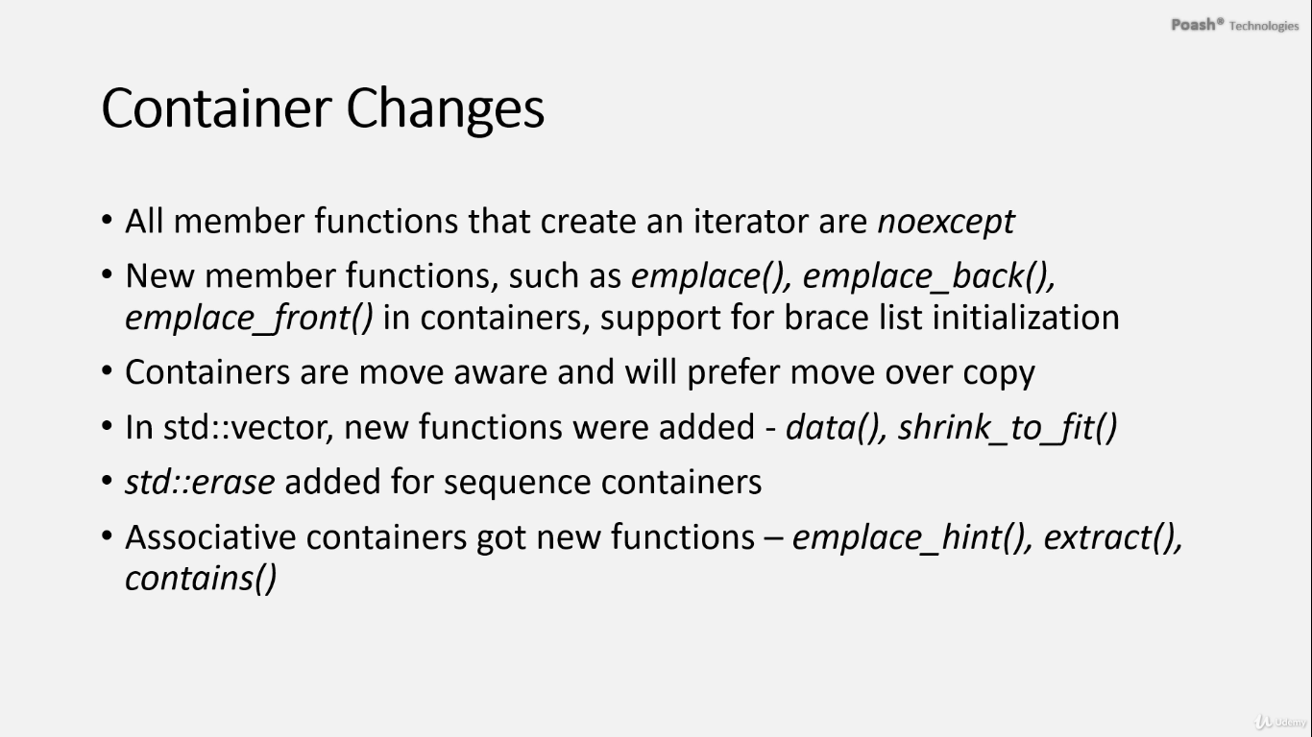

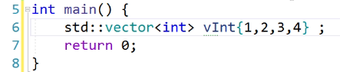

* In C++, if you want to initialize a container like a vector with predefined values, you can use brace list initialization. This method works for all containers.
* Before C++11, you had to use functions like **push_back** or **insert** to initialize a container. However, with brace list initialization, you can initialize the container as soon as it's created, making the code more concise and readable.

# push_back and emplace_back

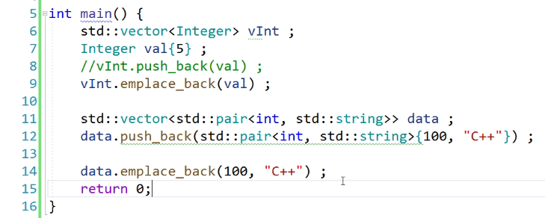

The introduction of in-place functions like **emplace_back** in C++ containers presents a powerful alternative to traditional insertion methods like **push_back**. To better understand this distinction, let's delve into an example using a vector containing a custom type, **Integer**.

In our scenario, **Integer** follows ownership semantics, complete with essential functions like constructors, copy operations, and move operations. Each operation is designed to report its invocation on the console, providing us with valuable insight into object creation.

When utilizing **push_back** to add an integer value, such as **5**, to our vector, the value undergoes conversion into an **Integer** object. This process invokes a parameterized constructor followed by a constructor call, resulting in the creation of two objects.

On the other hand, employing **emplace_back** allows us to directly initialize an **Integer** object within the vector using the provided value. As a consequence, only one object is constructed, directly within the vector itself. This streamlined approach is evident from observing only a single parameterized constructor call.

The decision between **push_back** and **emplace_back** hinges on whether objects are already constructed or need to be constructed with values during insertion. If objects are readily available and can be directly added to the container, both functions yield similar results. However, when objects are yet to be constructed, **emplace_back** shines by constructing them directly within the container, thereby reducing unnecessary object creation and potentially enhancing performance.

Moreover, the flexibility of **emplace_back** extends to its ability to accept an arbitrary number and type of arguments. This feature facilitates the construction of objects with varying parameters directly within the container, enhancing versatility and convenience.

In summary, while both **push_back** and **emplace_back** serve the purpose of adding elements to containers, **emplace_back** offers a more efficient and adaptable approach, particularly when constructing objects directly within the container is desired. This functionality not only improves code readability but also enhances performance, making it a valuable tool in modern C++ development.

# Noexcept with move Operations

In the realm of containers, C++ leans towards utilizing move operations over copy operations when multiple operations are involved. However, there's a subtle nuance to consider, best illustrated through the behavior of vectors.

Let's take a vector of integer objects and use **emplace_back** to populate it with a few integers. Upon addition, there's a chance that the vector might undergo reallocation to accommodate the new elements. This reallocation process becomes evident through calls to constructors or copy operations.

Upon inspection, we observe a parameterized constructor call for the first integer object added via **emplace_back**. Subsequently, another parameterized constructor is invoked for the object initialized with the value 2, followed by a copy constructor call.

This copy operation raises a question**: why does the vector resort to copy operations instead of move operations during reallocation?**

The answer lies in ensuring **the safety and reliability** of the reallocation process. When the vector reallocates, **it must guarantee** that while moving objects from the old memory to the new memory, the corresponding move operations must not throw exceptions.

Should a move operation encounter an exception during this critical process, the vector risks becoming invalid, as some objects may have already been moved into the new memory space. Subsequent exceptions during further move operations would complicate the vector's ability to revert to its original state.

To address this concern, the vector prioritizes move operations marked with the **noexcept** specifier. This specifier indicates that the operation is exception-safe, ensuring that no exceptions will be thrown during the move process.

By applying the **noexcept** specifier to move operations in the integer class, we provide assurances that these operations will not throw exceptions. Consequently, upon rebuilding and running the program, we observe the vector utilizing the move constructor instead of the copy constructor during reallocation.

In conclusion, when storing custom types in containers, it's **imperative** to mark operations with the **noexcept** specifier, ensuring exception safety, particularly during reallocation scenarios. This approach fosters robustness and reliability within container operations, contributing to a more resilient codebase.

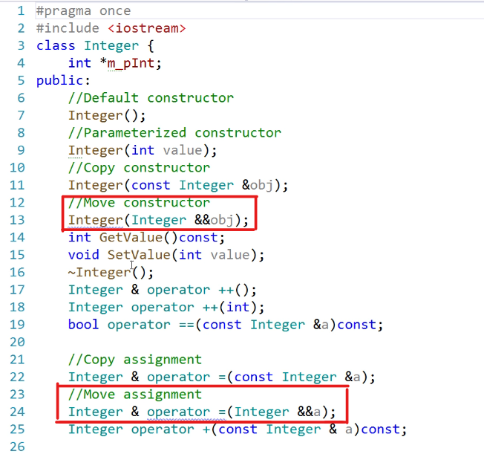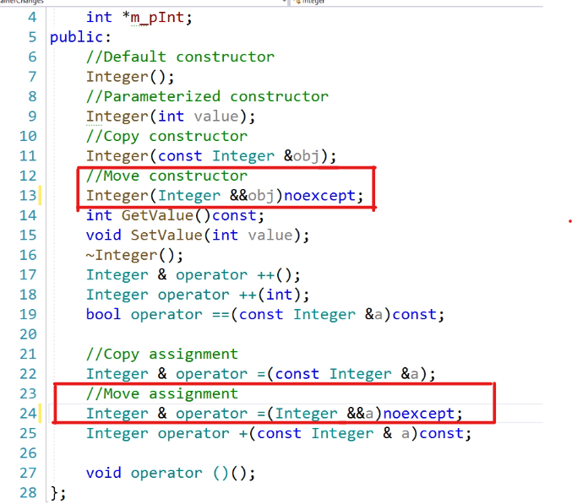

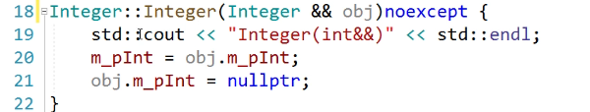

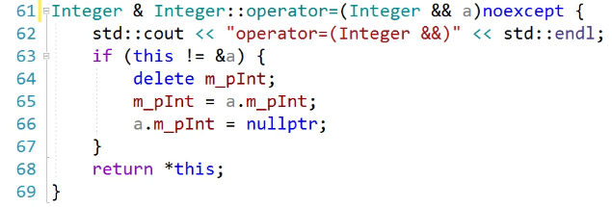

# Vector Functions

# shrink_to_fit

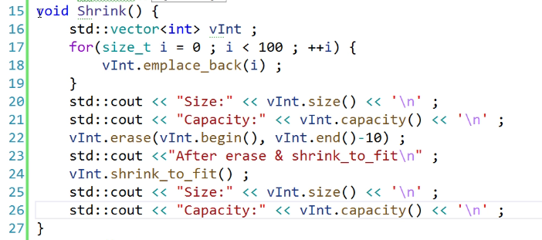

First, we initialize a vector of integers and populate it with elements using either **push_back** or **emplace_back** in a loop. After adding 100 elements, we examine the vector's size and capacity.

in your case, even though you start with 100 elements, the vector may allocate memory for more than just those 100 elements to allow for **future growth**. The **capacity of 141** indicates that the vector has allocated memory for up to 141 elements, while the **size remains** **at 100** because that's the number of elements you've actually inserted into the vector.

Upon inspection, we notice that when the vector's size equals its capacity and we attempt to add more elements, the vector reallocates, increasing its capacity. This reallocation involves allocating new memory, copying existing elements to the new memory, and then releasing the old memory.

**Now, what happens when we remove elements from the vector?** Surprisingly, even after removing elements, the vector's capacity **remains unchanged**. This behavior can be problematic, especially when dealing with large vectors, as it leads to memory wastage.

To address this issue, C++ introduced the **shrink_to_fit** member function for vectors. **This function reduces the vector's capacity to match its size**, reclaiming any excess memory allocated by the vector. Consequently, memory efficiency improves, particularly in scenarios where memory optimization is essential.

By leveraging **shrink_to_fit**, we ensure that the vector utilizes memory more efficiently, minimizing wastage and enhancing overall performance.

# data()

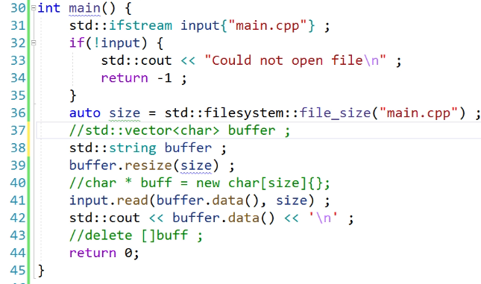

1. The function added to the vector, **data()**, provides direct access to the underlying buffer of the vector. This feature can be useful when you need to use a buffer for storing data without managing the memory of the buffer yourself.
2. This capability becomes handy, for instance, when you want to read data from a file.
3. Instead of manually managing memory allocation and deallocation for the buffer, you can leverage the **data()** function of the vector.
4. For instance, if you're reading data from a file, you can allocate memory dynamically for the buffer using **new**.
5. However, it's important to note that reading data into a fixed-size buffer is not ideal, especially if the file may contain more data than the buffer can hold.
6. In a more robust approach, you should dynamically allocate memory for the buffer based on the size of the file.
7. To achieve this, you can utilize functionalities provided by the C++17 standard library, such as those in the filesystem library.
8. After allocating memory for the buffer, ensure that you properly manage its memory, including releasing it when it's no longer needed.
9. Using a vector provides a more convenient and safer alternative to manually managing memory for the buffer.
10. You can create a vector of characters and resize it to the size of the file, effectively eliminating the need for manual memory management.
11. By using the **data()** function of the vector, you can obtain a pointer to the underlying buffer without having to manage its memory explicitly.
12. This approach simplifies your code and reduces the risk of memory-related bugs or issues.
13. Similarly, you could use a **std::string** instead of a vector for managing the buffer. However, ensure that you handle buffer overflows or underflows properly to avoid undefined behavior.
14. In summary, if you need to use a buffer for storing data without the hassle of manual memory management, leveraging the vector's **data()** function can be a convenient and safer option.

# std::erase

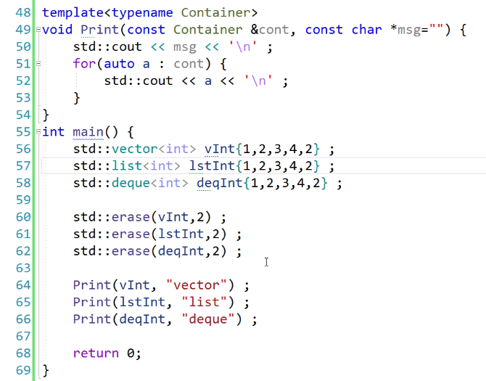

1. Previously, removing an element from a vector based on its value required using the erase-remove idiom, which was cumbersome.
2. Unlike other containers like lists, vectors only provided an **erase** function that accepted an iterator, removing elements based on their positions rather than their values.
3. This inconsistency between containers made it challenging to remove elements from vectors based on their values.
4. However, lists had a **remove** function, allowing elements to be removed based on their values, providing a more convenient approach.
5. In C++ 20, a new function called **std::erase** was introduced to address this inconsistency.
6. **std::erase** can be used to remove elements based on their values in various sequence containers, including vectors and lists.
7. To demonstrate, let's create a vector and a list of integers, and then remove some elements based on their values using **std::erase**.
8. Remember to compile the code with C++ 20 support enabled in the project properties to utilize the **std::erase** function

# Container Changes - Associative Containers

# emplace_hint()

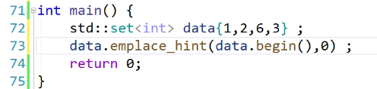 Top of Form

The **emplace** function allows for the direct construction of an object within the container's memory. In the context of associative containers like sets, there's another function called **emplace_hint**, which takes two parameters: an iterator and the value to be inserted.

The first parameter, the iterator, acts as **a hint for the container**, indicating where the element might be inserted. This helps in optimizing the insertion process by placing the new element as close as possible to the hinted position.

Since **emplace_hint** constructs the element directly within the container's memory, it avoids unnecessary copy or move operations, making the insertion process more efficient.

The advantage of using **emplace_hint** becomes evident when you already have an iterator close to the insertion position. In such cases, the insertion operation can be significantly faster compared to regular insertions that don't utilize the hint.

An example provided in the documentation demonstrates the difference in insertion time with and without the hint. When using **emplace_hint**, the insertion time was reduced to almost half compared to regular insertion. However, using the wrong hint may lead to longer insertion times.

Therefore, if you have an iterator close to the insertion position, it's beneficial to use **emplace_hint** for inserting elements into the container.

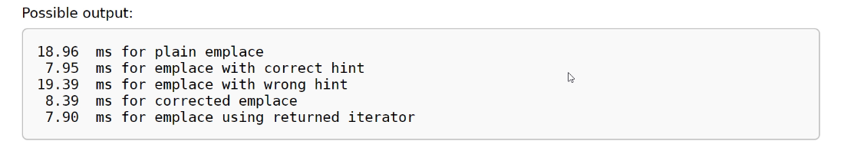

# contains

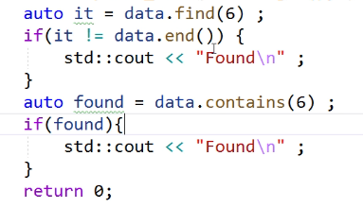

In previous versions of C++, checking if an element exists in an associative container, like a set, required using the **find** function. This approach involved obtaining an iterator to the found element or pointing to the end of the container if the element didn't exist. However, this method was cumbersome and involved unnecessary steps.

Luckily, C++ 20 introduced the **contains** function, which simplifies this process by returning a boolean value indicating whether the specified value exists in the container. This eliminates the need to obtain an iterator and compare it against the end of the container.

Let's demonstrate this with an example using a set of strings. Suppose we want to update the first letter of a name in the set. First, we search for the element inside the set. If found, we get an iterator to the element. However, since the iterator is constant, we cannot directly update the value it points to. This limitation prevents disruptions to the natural order of the set, which could invalidate its structure.

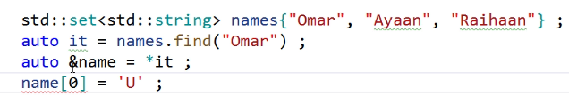

To update the value, **we need to create a copy of the element, erase the original element from the set,** and then insert the updated element. While this approach works, it relies on copy operations and may not be suitable for **non-copyable types**.

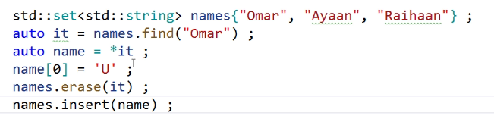

Therefore, dealing with non-copyable types presents limitations, especially when updating values within the set. In such cases, alternative strategies must be employed.

# Using extract

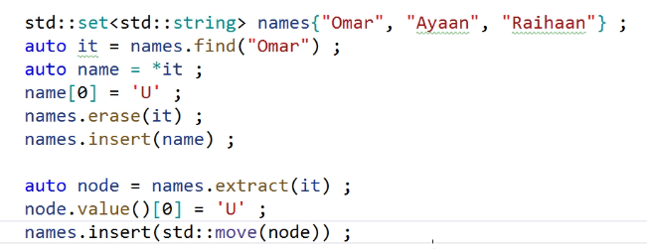

In C++17, a new function called **extract** was introduced for associative containers like set or map, which facilitates easy updating of values inside them. This function can take either the iterator of the element or the element itself. Since we already have the iterators, let's pass them.

The **extract** function returns a type that represents the node where the element is stored. This node provides access to the underlying element through a function called **value**. Thus, to update the element, we can directly modify it using this access. Once the element is updated, we can move this node back into the set or map.

It's worth noting that the node is non-negotiable, so we must move it back into the container. This process ensures that the element is not copied anywhere, and the original element is modified directly.

Overall, using the **extract** function provides a much better way of updating values inside associative containers compared to previous methods.

Additionally, it's important to mention that the **extract** function is also available for multisets, multimaps, unordered sets, unordered multisets, unordered maps, and unordered multimaps.